KAPLAN SINGAPORE

COMPULSORY ASSESSMENT

FEEDBACK SHEET

|  |  |  |  |
| --- | --- | --- | --- |
| **NAME:** | **CHUA KAI FENG** | **PRID:** | **CHUAK53109** |

|  |  |  |  |
| --- | --- | --- | --- |
| **Module Code:** | **CE301** | **Title:** | **Individual Capstone Challenge** |

**In addition to the feedback below, please consult the generic feedback on Moodle.**

**Comments:**

**Key areas for improvement:**

|  |  |  |  |
| --- | --- | --- | --- |
| **Mark:** |  | **Grade:** |  |
| Marker: |  | Date: |  |

|  |  |  |  |
| --- | --- | --- | --- |
|   **Assignment Coversheet**   * **Please complete and attach this form to your assignment. All assignments must be submitted on the stipulated submission date.**   **Program / Intake : PT UOE BScCS 4**  **Pathway: Bachelor of Science (Honours) in Computer Science**  **Assignment Type** *(optional)***: Final Report** | | | |
| **Student Name:** | **CHUA KAI FENG** | **Student Number (PRID):** | **CHUAKA53109** |
| **Module Code:** | **CE301** | **Module Title:** | **Individual Capstone Project Challenge** |
| **Lecturer/Tutor:** | **Mr Kang Leng** | **Grade:** |  |
| **DECLARATION: I hereby declare that the attached assignment is my own work. I understand that if I am suspected of plagiarism or another form of cheating, I will be subject to disciplinary actions.**  **Signed: Date Submitted: 16/11/2023** | | | |

Start your coursework writing in this page onwards:

**E-commerce Web Application**

**Anything & Anywhere**

Student Information:

* Name: Chua Kai Feng
* Student ID & PRID: CT0369458 & CHUAK53109

Supervisor Information:

* Supervisor: Hai Kian
* Second Assessor’s Name: Gao Ziyuan

Degree Course:

* Course Title: Bachelor of Science (Honours) in Computer Science

Acknowledgements

I would like to express my deepest gratitude to those who supported me throughout this project and my degree journey. First, I am incredibly thankful to my mother for her sponsorship and unwavering encouragement, and to my father for lending me his car, which made travelling between my camp and school more manageable.

A special thank you to Mr. Kang Leng for imparting invaluable knowledge and guidance, as well as to my supervisor, Mr. Hai Kian, for his constant encouragement and unique ideas that pushed me to think outside the box. I am also grateful to my classmates Samuel, Colin, and Brian who stood by me throughout the entire course, making this journey all the interesting. I will always remember our Kebab days.

I extend my appreciation to online resources, especially forums like Stack Overflow, Colt Steele's Web Development Bootcamp, and Mozilla’s MDN for their comprehensive resources on web development. Additionally, I drew inspiration from e-commerce giants such as Shopee, Lazada, Amazon, Grab, and NTUC, which served as reference points for building a practical and user-friendly platform. Interestingly, the initial concept for my shopping platform stemmed from my experiences with NTUC.

To everyone who contributed directly or indirectly to the completion of this project, I offer my sincere thanks.

Abstract/Summary

Anything & Anywhere is an e-commerce platform designed to bring physical retailers and digital marketplace together. The platform pulls products from shopping malls, including food and beverages, clothing, groceries, etc. Hence, we provide clients with a comprehensive and convenient one-stop shop all-shopping solution. Anything & Anywhere aims to bring in features such as search and filtering capabilities, real-time inventory updates and an integrated AI Chatbot for better purchase decisions.

The platforms’ integration of AI-powered virtual shopping assistants enhances customer engagement by offering personalized recommendations.

This project has case studies that highlight the significant impact of e-commerce adoption on businesses, showcasing an increase in sales, expansion of customer base, improvements in operational efficiency and expanded scalability. By implementing e-commerce solutions into a business model, small businesses can expose themselves to the digital world, leading to significant increases in market reach and customer engagement.

We believe that this project offers a model for broader e-commerce adoption, especially for small to medium businesses looking to stay competitive in an evolving digital world.

Acknowledgements: We would like to thank Amazon, Shopee, Lazada, Grab and NTUC for serving as a reference point for our web application development throughout this project.

Table of Contents

Chapter 1: Introduction

* 1.1 Introduction
* 1.2 Today’s E-commerce Market
* 1.3 Problem Statements
* 1.4 Problem Solutions
* 1.5 Features
* 1.6 Goals & Objectives

Chapter 2: Background

* 2.1 Why I have Chose This Project
* 2.2 Project Elaboration
* 2.3 Similar Project Concept
* 2.4 Analysis

Chapter 3: Construction

* 3.1 Methodology
* 3.2 Selected Methodology
* 3.3 Design Phase
* 3.4 Risk Management
* 3.5 Use Case Diagram
* 3.6 Database Design
* 3.7 User Interface / User Experience Wireframe
* 3.8 User Interface / User Experience Drafting
* 3.9 Tech Stack
* 3.10 System Design

Chapter 4: Development

* 4.1 Prerequisites
* 4.2 Let’s Start
* 4.3 Frontend Development
* 4.4 Backend Development
* 4.5 Database Integration
* 4.6 AI Chatbot Integration

Chapter 5: Testing

* 5.1 Functional Testing
* 5.2 Performance Testing
* 5.3 Compatibility Testing
* 5.4 User Feedback

Chapter 6: Project Planning

* 6.1 Project Planning With Jira
* 6.2 Risk Management

Chapter 7: Conclusion

* 7.1 Achievements
* 7.2 Challenges Encountered
* 7.3 Future Improvements
* 7.4 Final Thoughts

Chapter 1: Introduction

1.1 **Introduction**

The E-commerce space has been growing rapidly over the recent years, revolutionising how consumers shop, and businesses run. With the expanding presence of the internet, e-commerce exposure to the market has been ever-growing ever since. You can access such services from anywhere in the world, instead of physically going to the physical store itself to shop. People in general are getting lazier as the quality of life is improving.

According to recent projections, e-commerce sales in Singapore are expected to reach **S$19.6 billion by 2027**, even as the growth rate begins to moderate. [1] Let me explain why e-commerce is growing. Firstly, it is more cost-effective to run an e-commerce web store than a physical store, as there is no real estate involved. Secondly, not much manpower is needed because Artificial Intelligence can replace human jobs. For example, chatbot assistance, instead of a person physically assisting consumers in the retail store. Thirdly, e-commerce recognises no time zone, it operates 24 hours a day non-stop. Fourthly, the operation automates itself, with no checking of stock since it is already stated there and no cashiering duties as all payments are through online. Fifth, it opens another presence for businesses, in a world that is forever running 24/7. These 5 reasons alone are enough for businesses to hop on the e-commerce joyride.

1.2 **Today’s E-commerce Market**

The E-commerce scene today only has independent store owners listing their products independently. This is how many big e-commerce giants begin, e.g. Gym Shark Glossier etc. But it doesn’t capture the essence of having a shopping mall where multiple stores offer a vast range of products and services under one “digital umbrella”.

Why this concept? Instead of physically going to the mall to do “retail therapy”, consumers can do it “online”. Sometimes we just want the idea of shopping, so we aimlessly head to the shopping mall. But instead of heading down physically, you can do “retail therapy” at your fingertips, the best part is you shop at “Parkway Parade” & “Jewel” at the same time.

1.3 **Problem Statements**

1.3.1 Non-Adoption By Certain Business

Despite the widespread adoption of e-commerce, some businesses, especially lesser-known shops tucked away in shopping malls, have yet to incorporate it into their business model. Some of these businesses are owned by traditional entrepreneurs who rely on human traffic and word-of-mouth sales. The concept of “online shopping” can feel foreign, not required and risky causing them to neglect the benefits of digital platforms.

1.3.2 Physical Service Providers

Businesses that primarily offer in-person or physical services face unique challenges in the implementation of e-commerce. Unlike products-based businesses, they can sell, pack & deliver products. This dependency on physical presence limits the implementation of conventional e-commerce models as they can’t simply list products for sale online. Hence relying on marketing to expand their reach and presence. The web app will counter this issue, by allowing the booking of physical services according to their availability.

1.3.3 Stock Availability For Retail Shopping

One of the most frustrating for the consumer and for me too, is the uncertainty of stock availability. There is no way to know the stock visibility until you are physically there to verify but if there isn’t any you will have to go to another place or go home. The web app will counter this issue by showing the stock availability in the web app, this is for people who like to feel the products before buying.

1.3.4 Speed Of Logistics

In Singapore, the e-commerce scene is trying to meet consumers’ demands for super-fast delivery like same-day fast. Meanwhile, in China, the e-commerce counterpart Taobao offers same-day delivery in certain regions and their region's landscape is far bigger than Singapore. There are some scenarios that a fast delivery can save lives.

1.3.5 Consolidated Checkout

Let’s take big e-commerce brands such as Shopee & Lazada as an example. If the consumer wants to buy from shop A & shop B, it would need to pay twice the shipping fee due to separate businesses, regardless of whether it is in the same location or warehouse since it is a “shopping mall” e-commerce store, why not consolidate all the delivery to one affordable price since you are specifically purchasing it from a shopping mall.

1.4 **Problem Solutions**

Does Singaporeans appreciate the idea of Shopping Mall E-commerce?

Yes, Singaporeans would likely appreciate a shopping mall e-commerce platform due to their strong preference for convenience and efficiency. This platform provides access to an extensive selection of products from various stores, offering both variety and a sense of nostalgia, as many Singaporeans have a “childhood mall” where they’ve spent time over the years.

For local brands and traditional businesses that haven’t gone digital, the platform offers a way for customers to continue supporting them with the ease of online shopping. Additionally, the concept of consolidated shipping costs across multiple stores in the same mall is appealing, as it allows customers to shop more broadly while saving on delivery fees.

The platform would also benefit in-person service-based businesses like salons, fitness centres, and tuition centres by allowing online booking and payment. This minimizes wait times, enables convenient appointment management, and removes the need for customers to call or visit to reschedule.

Moreover, incorporating loyalty programs, such as those offered by mall management companies like Land Lease, adds further value. Customers can earn points and rewards for their online spending, integrating the familiar loyalty experience into the e-commerce platform.

This concept blends familiarity with modern convenience, creating a digital shopping mall experience that caters to Singaporean preferences and lifestyles.

1.5 **Features**

* Extensive Product Catalogue: With a huge selection of products, spanning across multiple categories and shopping malls, user can select their favourite shopping mall and enjoy a one-stop shop all experience.
* Advanced Search and Filtering: With a search and filtering system, consumers are able to quickly locate specific products or services with optimal precision. The search system only works on the current shopping mall that the consumer selected.
* AI Chatbot Assistance: Online Shopping Assistant provide informative decision and product recommendations, directions and general enquiries. Improving interaction with consumers and providing trends to make decisive business decisions.
* Real-Time Inventory Updates: Consumers can check the stock availability before travelling down to look at the product and make a purchase decision. Also to reduce the risk of disappointment.
* Interactive User Dashboard: A easy to understanding dashboard to give users access to all dashboard features including order tracking, appointment management, reward points, update of information, payment methods and update of address.
* Interactive Seller Dashboard: An easy-to-understand dashboard where sellers can Create, Read, Update and Delete products, access performance analytics and view customer interactions from the chatbot.
* Seamless Transaction: A smooth checkout and payment process.

1.6 **Goals & Objectives**

1.6.1 Goals

The aim of *Anything & Anywhere* is to transform the traditional shopping mall experience into a seamless digital platform, providing users with convenient access to a wide range of products and services from multiple stores in one location.

It seeks to support business owners by driving an additional stream of traffic and simplifying e-commerce adoption for those without an online presence.

Additionally, the platform provides increased business opportunities for logistics partners by generating a higher volume of deliveries through a centralized system. With multiple stores joining the platform, logistics providers gain more consistent orders and the ability to manage consolidated shipments from various shops within a single delivery route.

1.6.2 Objectives

The following objectives for this project are by the software development methodology. They aim to ensure an efficient, user experience focus and scalable development.

* Deliver an Intuitive User Experience: Develop a platform with a user-friendly interface and advanced features like real-time search, filtering, and inventory updates to meet customer needs efficiently.
* Ensure Scalable Architecture: Build a scalable system that can handle increasing numbers of stores, products, and users without compromising performance, supporting the platform’s long-term growth.
* Enable Comprehensive Seller and Buyer Dashboards: Implement interactive dashboards for both sellers and buyers, providing easy access to sales metrics, inventory management, and purchase history.
* Focus on Continuous Improvement and Feedback: Adopt an iterative development process to continually refine features based on user feedback and emerging needs, maintaining a high-quality product.

Chapter 2: Background

2.1 **Why I Have Chosen This Project**

Before we begin presenting the poster, let me provide a brief introduction to the background of this project.

The decision to pursue this project stems from my personal experience in e-commerce during the COVID-19 pandemic in 2020. When the pandemic struck Singapore, it became almost impossible to find part-time jobs during term breaks, as most businesses were forced to close. However, one industry that continued to operate was courier services, which allowed e-commerce to thrive even in the most challenging times. That was the moment I realized the resilience of e-commerce, and I decided to give it a try.

I started with selling rubber-resistant bands, as I, along with other gym enthusiasts, was looking for ways to stay fit while stuck at home. Unfortunately, that venture didn’t take off as I had hoped, since many people turned to bodyweight workouts that didn’t require equipment. However, what turned out to be successful was selling thermal water bottles, which met a practical need during quarantine—people preferred not to refill their hot water constantly, so the bottles became a popular solution.

Through this journey, I realized that e-commerce operates around the clock, and once orders are fulfilled, the business essentially runs itself. My focus shifted to the user experience (UX) and user interface (UI), as well as the marketing of the products. Initially, I used a web builder platform, Shopify, but I found it too restrictive in terms of design flexibility. That’s when I realized the power of building a website from scratch using HTML and CSS, where I could create anything I envisioned, offering the flexibility and control I needed.

2.2 **Project Elaboration**

2.2.1 Why Was Internet Services Selected For This Project

Internet Services was as chosen as the base for this project because it enables world wide accessibility and connectivity across different devices and user groups. With e-commerce being the only other shopping method than retail shopping / “retail therapy”, it allows users to browse and purchase the products anytime and anywhere.

2.2.2 Why Was Web-Based Application Chosen For This Project

A web-based application user a website as the interface platform (Front End / Client Side).

2.3 **Similar Project Concept**

2.3.1 Shopee

A notable aspect of Shopee's strategy is its focus on mobile-first development, catering to the high mobile internet usage in the region. The platform also integrates social features like live chat and interactive games to enhance user engagement. Additionally, Shopee has ventured into financial services with ShopeePay, its digital wallet, facilitating seamless transactions within the platform. Also ShopeePay can be used with participating merchants.

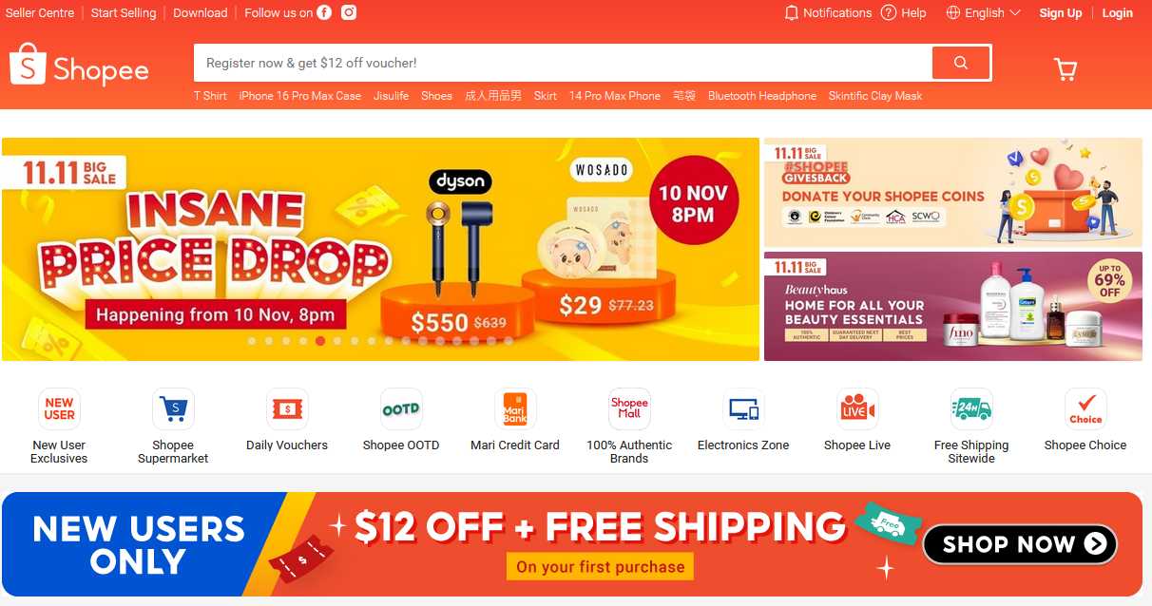

Figure 1 - Shopee

2.3.2 Lazada

Lazada provides comprehensive logistics and fulfilment services through its dedicated branch, Lazada Express, which allows sellers to manage to ship seamlessly. The platform includes LazMall, a premium section featuring authentic, brand-certified products from local and international brands, catering to consumers looking for trusted, high-quality items. Lazada takes a mobile-first approach to meet the needs of Southeast Asia’s high mobile usage, with an intuitive app for browsing, purchasing, and tracking orders. It also offers flexible payment options, including cash on delivery, credit/debit cards, and digital wallets, to accommodate diverse consumer preferences. A robust logistics infrastructure supports Lazada, ensuring timely deliveries across the region. Ever since Alibaba acquired a controlling stake in 2016, Lazada has benefited from Alibaba’s advanced e-commerce and logistics technology, enhancing its capabilities and solidifying its reach across Southeast Asia.



Figure 2 – Lazada

2.3.3 Amazon

A standout feature of Amazon is its Fulfillment by Amazon (FBA) service, which allows sellers to store products in Amazon’s warehouses. Amazon handles storage, packaging, and shipping, ensuring fast and reliable delivery for customers. Amazon Prime is another major component that enhances Amazon’s appeal and user experience. This membership program provides exclusive benefits, including free two-day shipping, same-day delivery in select locations, and Prime Video streaming access, which includes movies, TV shows, and original Amazon content. Prime members also receive access to Prime Music, a music streaming service, and Prime Reading, which includes books, magazines, and audiobooks.

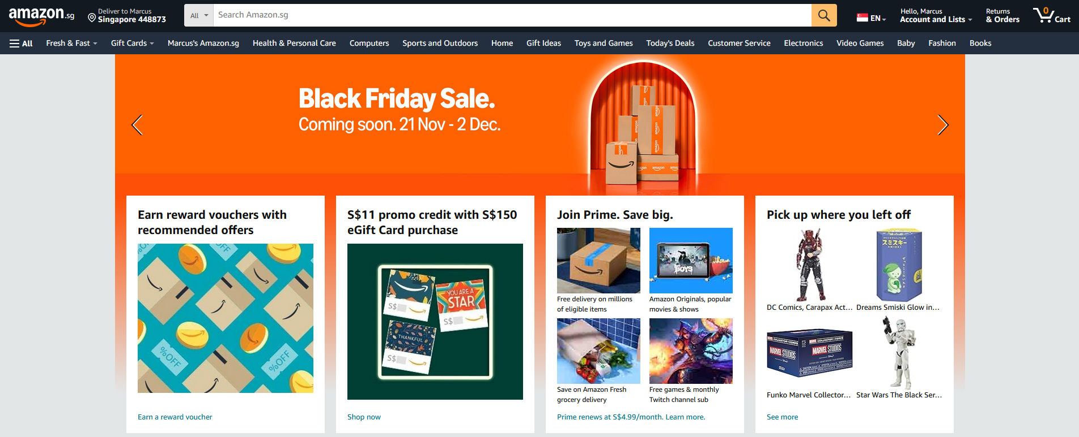

Figure 3 - Amazon

2.4 **Analysis**

The following figure is the tech stack that was used by the e-commerce giants such as Shopee, Lazada & Amazon.

|  |  |  |  |  |  |
| --- | --- | --- | --- | --- | --- |
| Platform | Frontend | Backend | Database | Cloud Infrastructure | Search |
| Shopee | React, Vue.js | Java, Node.js | MongoDB | AWS | Elasticsearch |
| Lazada | React. Vue.js | Java, PHP | MongoDB | Alibaba Cloud | Elasticsearch |
| Amazon | React, AWS Amplify | Java, Node.js | Aurora | AWS | Elasticsearch, Alexa |

Figure 4 – Tech Stack

The following figure is the feature comparison table that was implemented by e-commerce giants such Shopee, Lazada & Amazon

|  |  |  |  |
| --- | --- | --- | --- |
| Feature | Shopee | Lazada | Amazon |
| Design for Mobile | Check mark, Wingdings font, character code 252 decimal. | Check mark, Wingdings font, character code 252 decimal. | Check mark, Wingdings font, character code 252 decimal. |
| Live Stream | Check mark, Wingdings font, character code 252 decimal. |  |  |
| Own Logistics Network |  | Check mark, Wingdings font, character code 252 decimal. | Check mark, Wingdings font, character code 252 decimal. |
| Loyalty/Membership | Check mark, Wingdings font, character code 252 decimal. | Check mark, Wingdings font, character code 252 decimal. | Check mark, Wingdings font, character code 252 decimal. |
| Global Reach |  |  | Check mark, Wingdings font, character code 252 decimal. |
| Order Tracking | Check mark, Wingdings font, character code 252 decimal. | Check mark, Wingdings font, character code 252 decimal. | Check mark, Wingdings font, character code 252 decimal. |
| Chatbot Assistance | Check mark, Wingdings font, character code 252 decimal. | Check mark, Wingdings font, character code 252 decimal. | Check mark, Wingdings font, character code 252 decimal. |
| Account Creation | Check mark, Wingdings font, character code 252 decimal. | Check mark, Wingdings font, character code 252 decimal. | Check mark, Wingdings font, character code 252 decimal. |
| Checkout Procedure | Check mark, Wingdings font, character code 252 decimal. | Check mark, Wingdings font, character code 252 decimal. | Check mark, Wingdings font, character code 252 decimal. |
| Add To Cart | Check mark, Wingdings font, character code 252 decimal. | Check mark, Wingdings font, character code 252 decimal. | Check mark, Wingdings font, character code 252 decimal. |
| Add / Remove Items In Cart | Check mark, Wingdings font, character code 252 decimal. | Check mark, Wingdings font, character code 252 decimal. | Check mark, Wingdings font, character code 252 decimal. |
| Search and Filtering | Check mark, Wingdings font, character code 252 decimal. | Check mark, Wingdings font, character code 252 decimal. | Check mark, Wingdings font, character code 252 decimal. |

Figure 5 – Features Comparison

All three e-commerce platforms Shopee, Lazada & Amazon provide core fundamental e-commerce features such as account creation, check operations, cart functionality, etc. It fulfils the Create, Read, Update and Delete. However, Amazon’s AI assistant known as Alexa and Prime membership not only benefits users in shopping wise but also provides streaming/media services. While Shopee and Lazada have in-app games that allow the user to earn reward points and vouchers to further discount their purchases. Overall, all three e-commerce has their unique concept to attract different types of customers, which can be referenced to create our unique features.

Chapter 3: Construction

3.1 **Methodology**

3.1.1 Agile Methodology (Scrum)

Agile Methodology is a project management methodology that focuses on breaking down work into small manageable tasks called sprints. The duration for each sprint will last around 1-4 weeks. The Agile principles are,

* Customers through early, continuous improvement and delivery. [2]
* Welcome changing requirements, even late in the project. [2]
* Deliver value frequently. [2]
* Break the silos of your projects. [2]
* Build projects around motivated individuals. [2]
* The most effective to communicate is face-to-face. [2]
* Working software is the primary measure of progress. [2]
* Maintain a sustainable working pace. [2]
* Continuous excellence enhances agility. [2]
* Simplicity is essential. [2]
* Self-organizing teams generate the most value. [2]
* Regularly reflect and adjust your way of work to boost effectiveness. [2]

The team is being spearheaded by a Scrum Master who will manage the task and clear the task effectively. The Scrum Master also ensures others their day-to-day work. Scrum team has their daily meetings to discuss tasks, risks and problems that may reduce the effectiveness of the development team.

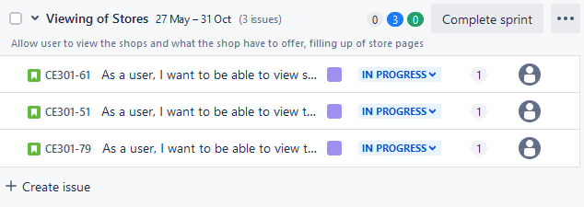

Figure 6 – Agile Methodology Visualization

3.1.2 Kanban Methodology

Kanban methodology is a project management methodology that focuses on task that has a few statuses such as e.g. “To Do”, “In Progress” and “Done” visualized on a Kanban board. These tasks are visualized as cards and stages are visualized as columns. The Kanban Principles are,

* Start with what you do now. [3]
* Agree to pursue incremental, evolutionary change. [3]
* Respect the current process, roles, and responsibilities. [3]
* Encourage acts of leadership at all levels. [3]

The team is managed by a Team Lead, which is also responsible for the Kanban Board, to visualize the process. They will also monitor the workflow from stage to stage and identify any potential risks that will decrease the effectiveness of the team.

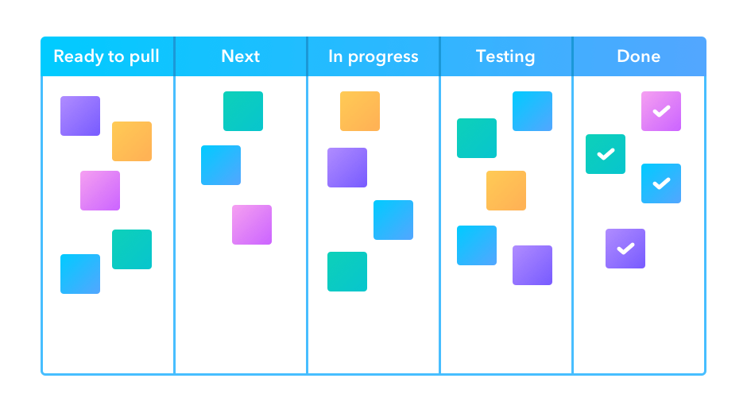

Figure 7 – Kanban Methodology Visualization

3.1.3 Waterfall Methodology

Waterfall methodology is a project management methodology that focuses on a downstream and sequential approach. Each phase of the project must be fully completed before proceeding to the next, so it is hard to go back to the requirements one implementation has begun. This approach has 5 stages, which are requirements, design, implementation, verification and maintenance.

* Strict, one-way structure.
* Little to no stakeholder involvement after the first stage.
* In-depth upfront documentation of the entire process.

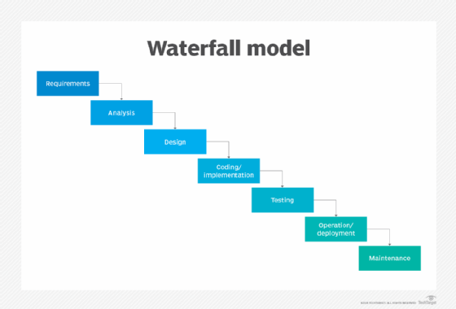

Figure 8 – Waterfall Methodology Visualization

Key Points Comparison

|  |  |  |  |
| --- | --- | --- | --- |
| Feature | Agile | Kanban | Waterfall |
| Approach | Iterative & incremental | Visual & continuous flow | Linear & Sequential |
| Flexibility | Highly adaptability | High adaptability | Low adaptability |
| Customer Involvement | End of each sprint | Anytime | Start and end of project |
| Phases | Sprints with daily meeting | Task moving on board | Fixed phases |
| Testing | Each sprint | Task by task basis | After development |
| Project Suitability | Evolving requirements | Continuous tasking | Fixed requirements |

Figure 9 – Key Points Comparison

3.2 **Selected Methodology**

Three types of methodologies were considered.

* Agile (Chosen One)
* Kanban
* Waterfall

Why Agile?

Adaptability: Projects need to be adaptable to frequent changes, especially when dealing with a lot of different clients. The clients will have different expectations and requirements, so we evolve as we go. Also, e-commerce is an evolving market, we need to be adaptable to new features or new technology updates.

Customer Involvement: Frequent client involvement is necessary; it is to help ensure the final product is within customer expectations. Any refining of the projects can be made along the way as the project goes.

Scrum allows you to prioritize and develop key features first, like the front end of the web application and some basic CRUD functions. This means you can launch an MVP (Minimum Viable Product) and keep developing in subsequent sprints

3.3 **Design Phase**

3.3.1 Sprint 1 Challenge Week Deliverables

|  |  |  |
| --- | --- | --- |
| Task/ User Stories | Story Point | Status |
| CE301-3 Background Reading | 1 | Done |
| CE301-9 Research on E-commerce | 1 | Done |
| CE301-4 Project Objectives | 1 | Done |
| CE301-5 Clear Management Plan | 1 | Done |
| CE301-6 Technical Achievements | 1 | Done |
| CE301-10 Research on Software for Front-end, Back-end | 1 | Done |
| CE301-7 Slides for Presentation | 1 | Done |

Figure 10 – Sprint 1

3.3.2 Sprint 2: Create UI

|  |  |  |
| --- | --- | --- |
| Task/ User Stories | Story Point | Status |
| CE301-18 Wire Frame | 3 | Done |
| CE301-13 UI Drafting | 3 | Done |
| CE301-14 Create Pages | 3 | Done |
| CE301-16 Documentation | 1 | Done |

Figure 11 – Sprint 2

3.3.3 Sprint 3: User Interface

|  |  |  |
| --- | --- | --- |
| Task/ User Stories | Story Point | Status |
| CE301-61 As a user, I want to be able to view shopping malls so that I can choose the preferred shopping locations | 5 | Done |
| CE301-51 As a user, I want to be able to view the shops so that I can that I know which brand I am buying from | 5 | Done |
| CE301-79 As a user, I want to be able to view the product so that I can purchase the desired product | 5 | Done |

Figure 12 – Sprint 3

3.3.4 Sprint 4: Shopping Cart

|  |  |  |
| --- | --- | --- |
| Task/ User Stories | Story Point | Status |
| CE301-75 As a user, I want to be able to view my shopping cart, so that I can checkout | 1 | Done |
| CE301-68 As a user, I want to be able to add item to cart, so that I can collate all my purchase | 1 | Done |
| CE301-52 As a user, I want to be able to delete item from the cart so that I can change my order | 1 | Done |
| CE301-70 As a user, I want to be able edit the quantity in the cart, so that I can | 1 | Done |

Figure 13 – Sprint 4

3.3.5 Sprint 5: Checkout Page

|  |  |  |
| --- | --- | --- |
| Task/ User Stories | Story Point | Status |
| CE301-75 As a user, I want to be able to view my shopping cart, so that I can checkout | 1 | Done |
| CE301-68 As a user, I want to be able to add item to cart, so that I can collate all my purchase | 1 | Done |
| CE301-52 As a user, I want to be able to delete item from the cart so that I can change my order | 1 | Done |
| CE301-70 As a user, I want to be able edit the quantity in the cart, so that I can | 1 | Done |

Figure 14 – Sprint 5

3.3.6 Sprint 6: User Account Administrative

|  |  |  |
| --- | --- | --- |
| Task/ User Stories | Story Point | Status |
| CE301-80 As a user, I want to be able to view my order history so that I can keep track of my spending | 1 | Done |
| CE301-58 As a user, I want to be able to change my personal information so that the right notification is send to the correction address | 1 | Done |
| CE301-52 As a user, I want to be able to change my payment information so that I can make purchase with the chosen payment method | 1 | Done |
| CE301-70 As a user, I want to be able to access my dashboard so that I can use the dashboard functions | 2 | Done |
| CE301-50 As a user, I want to be able to delete my account, so that I don't have any ties with the e-commerce | 1 | Done |

Figure 15 – Sprint 6

3.3.7 Sprint 7: Seller Account Management

|  |  |  |
| --- | --- | --- |
| Task/ User Stories | Story Point | Status |
| CE301-66 As a seller, I want to be able to upload products so that shoppers can see | 1 | Done |
| CE301-81 As a seller, I want to be able to track the inventory of the store, so that I can decide on whether to bring in more stock | 1 | Done |
| CE301-82 As a seller, I want to be able to see incoming orders, so that I can fulfil the orders | 1 | Done |
| CE301-62 As a seller, I want to be able to delete my account, so that I can withdraw from the system | 1 | Done |

Figure 16 – Sprint 7

3.3.8 Sprint 8: Poster and Abstract

|  |  |  |
| --- | --- | --- |
| Task/ User Stories | Story Point | Status |
| CE301-91 Create Poster | 1 | Done |
| CE301-92 Abstract | 1 | Done |

3.3.9 Sprint 9: AI Chatbot

|  |  |  |
| --- | --- | --- |
| Task/ User Stories | Story Point | Status |
| CE301-65 As a user, I want to be able to ask the chatbot for assistance so that I can make decisive purchases | 3 | Done |

Figure 17 – Sprint 9

3.4 **Risk Management**

3.4.1 Data Security

* **Risk Explanation**: Data theft and breaches can compromise user information, impacting trust and platform credibility.
* **Mitigation Strategy**: To protect user credentials, use hashed passwords (e.g., bcrypt) instead of plaintext.

3.4.2 Logistics

* **Risk Explanation**: Inefficient or unreliable delivery can negatively affect customer satisfaction and result in lost sales.
* **Mitigation Strategy**: Outsource the logistics to freelance logistics providers to enhance flexibility and scalability. Set clear performance expectations and service-level agreements (SLAs) to ensure timely and dependable delivery. Regularly monitor partner performance and gather feedback to adjust as necessary. Grab and Lalamove are perfect examples of freelance logistics providers

3.4.3 Site Maintenance

* **Risk Explanation**: Lack of consistent maintenance could lead to outdated features and content. Keeping promotion and sales updated is the key attraction point to e-commerce.
* **Mitigation Strategy**: Establish a structured maintenance plan, with clear responsibilities for both business owners (for their product and store updates) and the platform team (for core features, security patches, and system updates). Schedule routine maintenance checks, especially during off-peak hours, and provide business owners with guidelines for platform updates.

3.4.4 Coordination With Business Owners

* **Risk Explanation**: Poor communication or lack of alignment with business owners could impact their engagement with the platform. Their feedback is very valuable in our evolution and scaling.
* **Mitigation Strategy**: Foster open channels of communication and actively gather feedback from business owners to understand their needs. Each of these channels will be handled by a Customer Relationship Agent so that they can schedule regular check-ins, conduct surveys, and assist them with any issues or questions. They will have a fixed Customer Relationship Agent assigned to them, so they won’t feel like they are just talking to another helpdesk or AI chatbot. Basically like a Relationship Manager.

3.4.5 Technical Challenges

* **Risk Explanation**: Issues like downtime, traffic spikes, or technical malfunctions could disrupt service and frustrate users.
* **Mitigation Strategy**: Use cloud-based infrastructure with auto-scaling capabilities to handle fluctuations in traffic. Implement load balancing, caching, and failover mechanisms to reduce the risk of downtime. Regularly conduct performance tests and maintain a backup plan for unexpected outages, including a disaster recovery protocol.

3.4.6 Return And Refunds Of Goods

* **Risk Explanation**: Returns and refunds can generate negative costs due to additional logistics expenses. As it is expected of the business owner to bear the cost. “Returns are an Achilles heel for consumers and retailers” [4]
* **Mitigation Strategy**: Establish a clear returns and refunds policy that outlines conditions and costs for customers. Another consideration is to fulfil all refund requests regardless of the conditions, as customer service is top priority.

3.5 **Use Case Diagram**

The following use case diagram represent the interactions between Clients and Server in Anything & Anywhere e-commerce web application.

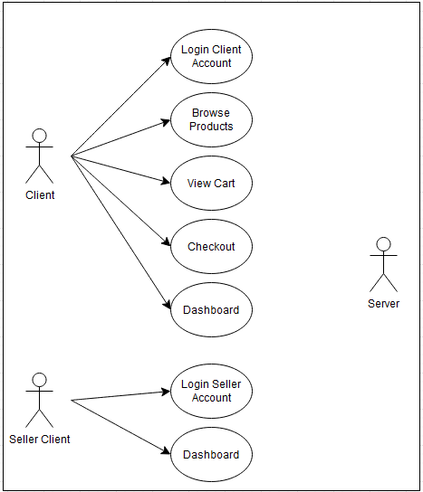

Figure 18 – High Level Use-Case Diagram

3.5.1 Browse Products

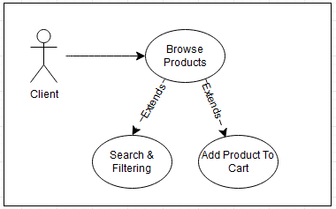

Figure 19 – Browse Products Use-Case Diagram

3.5.2 View Cart

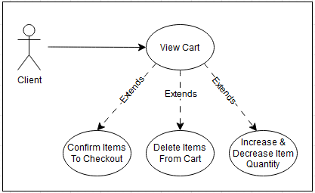

Figure 20 – View Cart Use-Case Diagram

3.5.3 Checkout

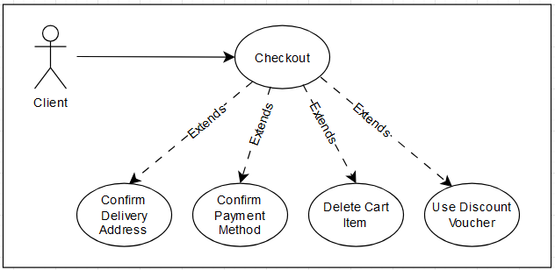

Figure 21 – Checkout Use-Case Diagram

3.5.4 Client Dashboard (Shopper)

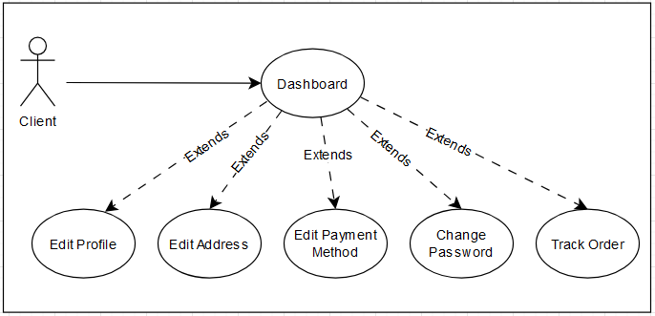

Figure 22 – Client Dashboard (Shopper) Use-Case Diagram

3.5.5 Client Dashboard (Seller)

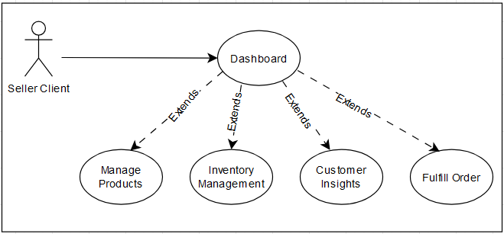

Figure 23 – Client Dashboard (Seller) Use-Case Diagram

3.6 **Database Design**

The database structure presents all of the interconnected tables for the management of data for the Anything & Anywhere e-commerce web application. The database structure is carefully designed with links to maintain data integrity across all tables and also make Anything & Anywhere more scalable.

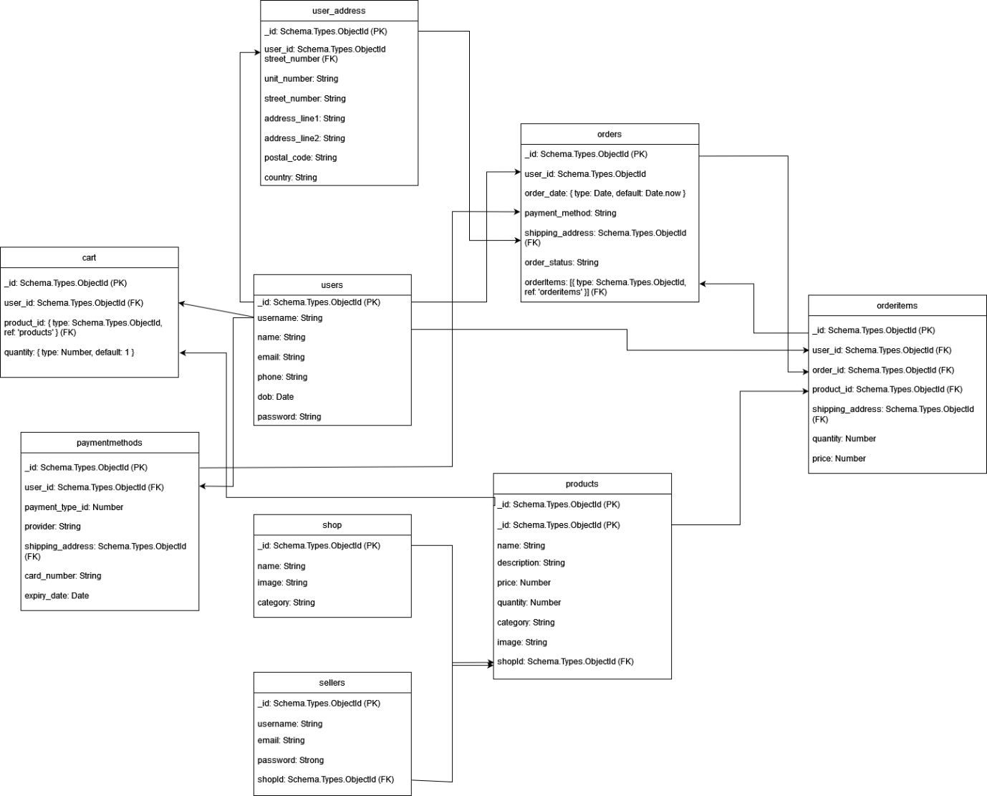

Figure 24 – Database Structure

3.7 **User Interface / User Experience Wireframe**

The UI / UX wireframing phase is very essential in the developing phase of the project, as it shows the developers the layout and functionality of the web application. Wireframing provides visualization of the navigation bar, main content, buttons etc, positioned. This phase is not only vital for developers, but it is also vital for Clients to visualise the flow and interactions and provide crucial feedback to help improve the development.

Prerequisites:

Tools that were used for Wireframing Draw IO.

3.7.1 Landing page

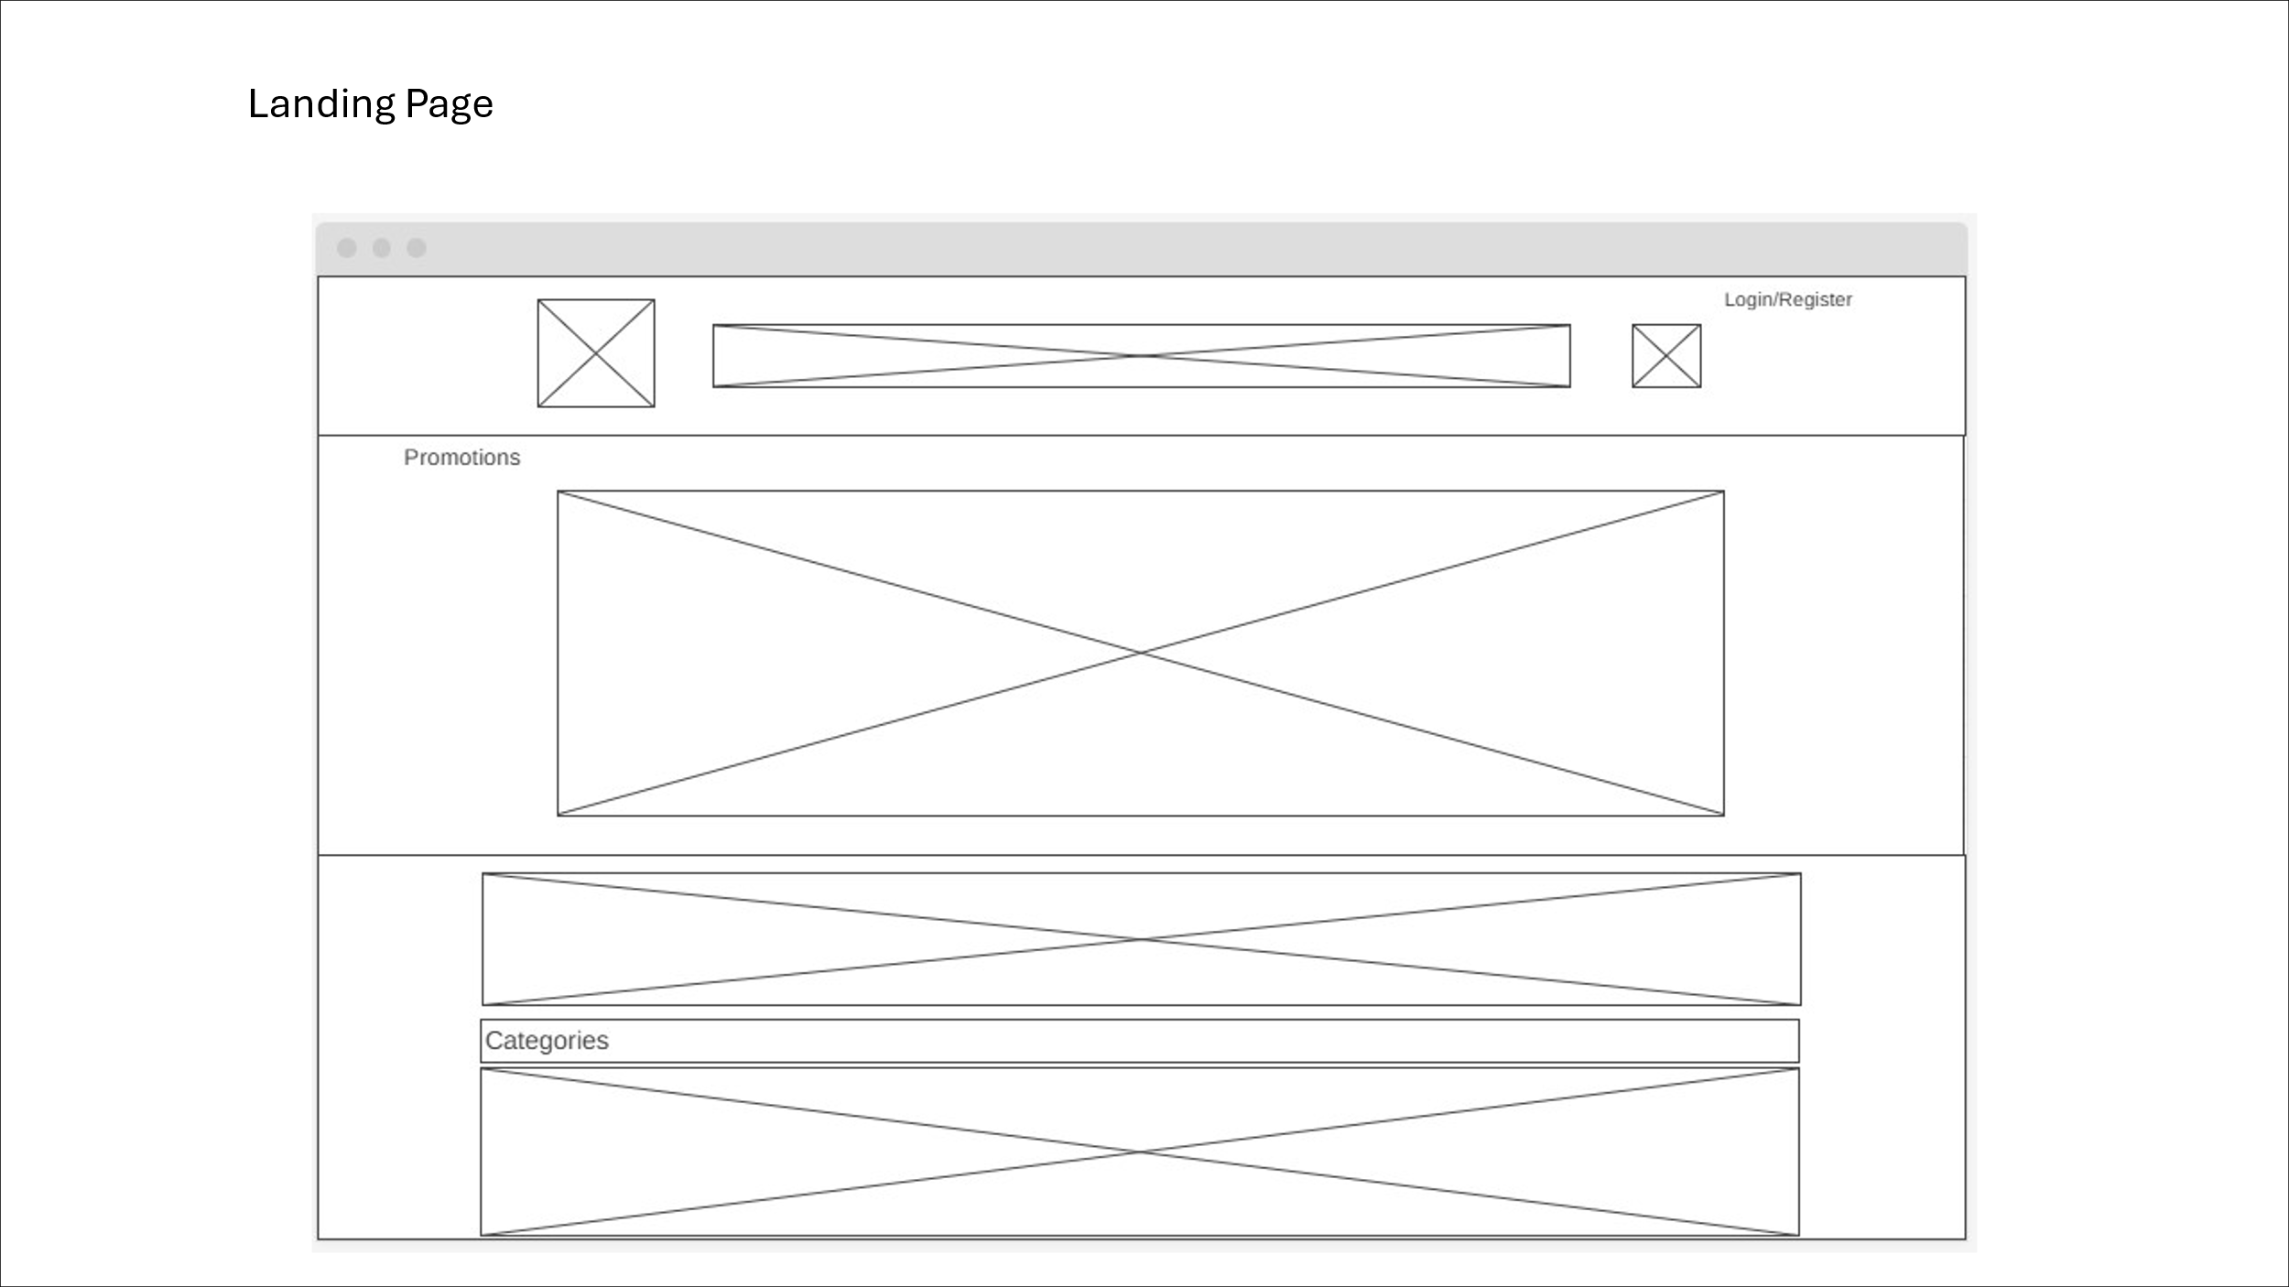

Figure 25 – Wireframe For Landing Page

3.7.2 Login Page

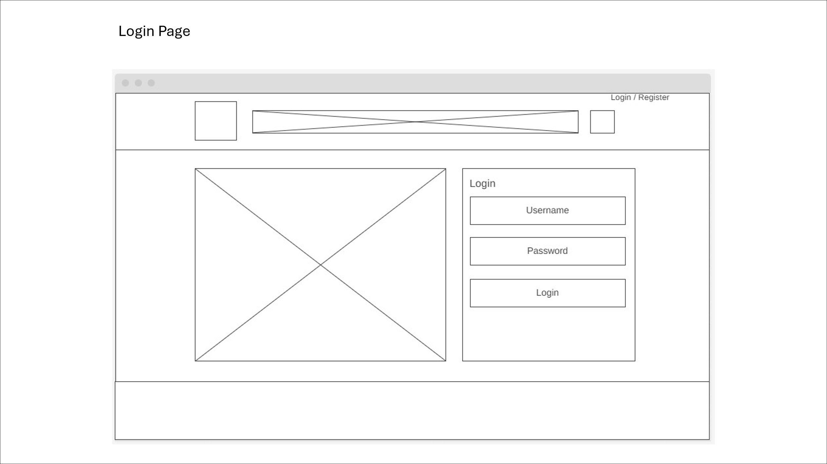

Figure 26 - Wireframe For Login Page

3.7.3 Register Page

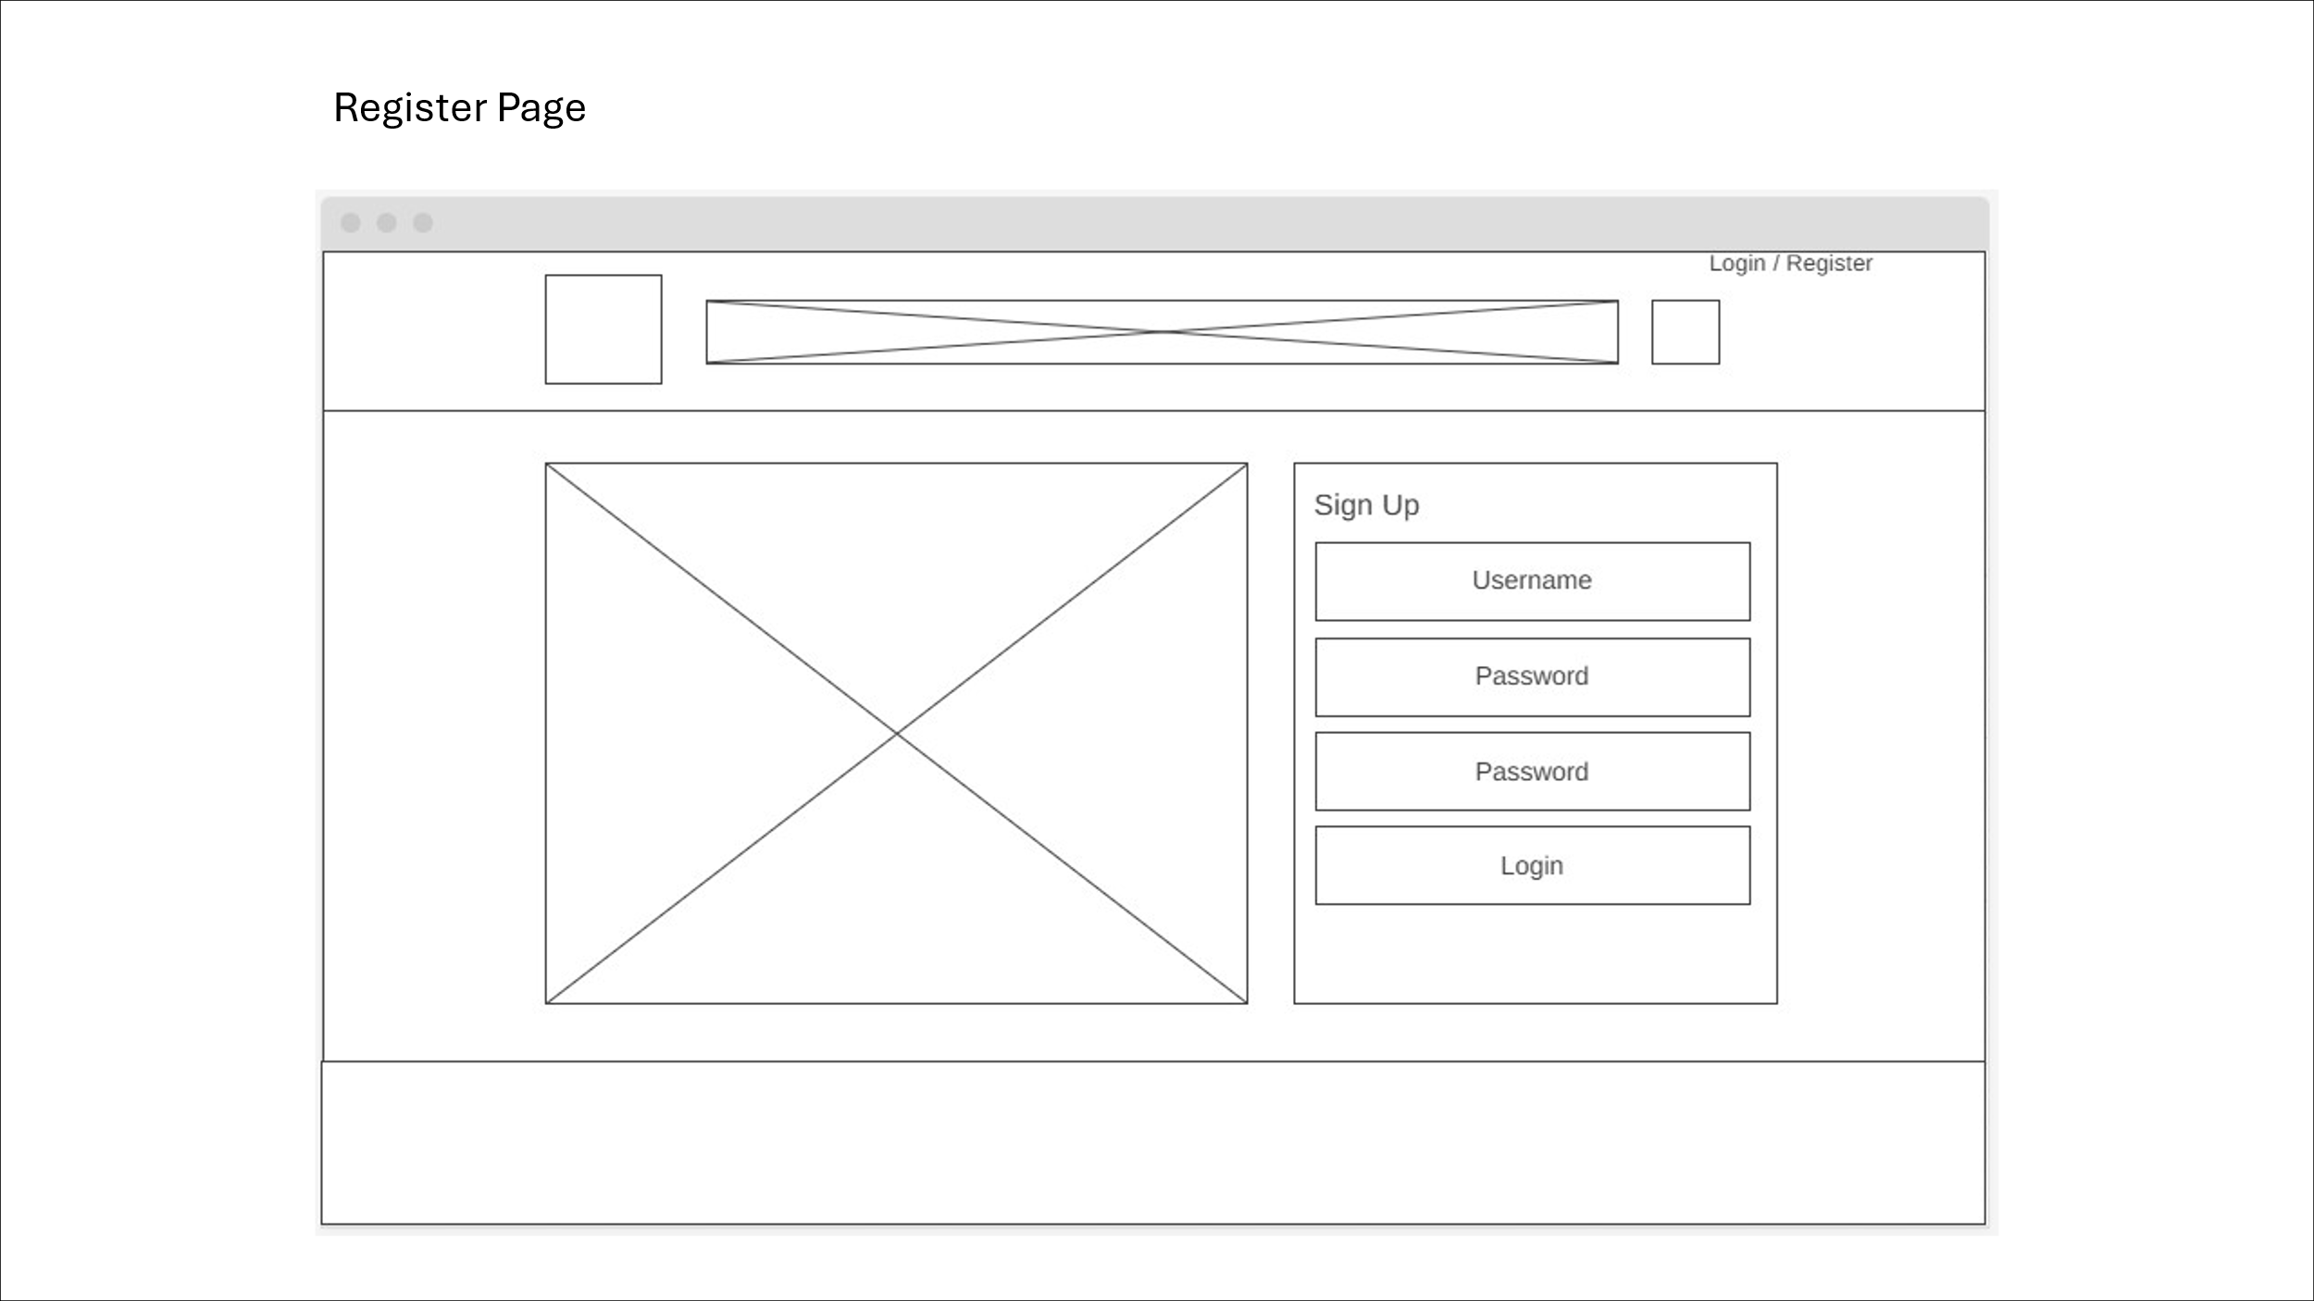

Figure 27 – Wireframe For Register Page

3.7.4 Dashboard Page

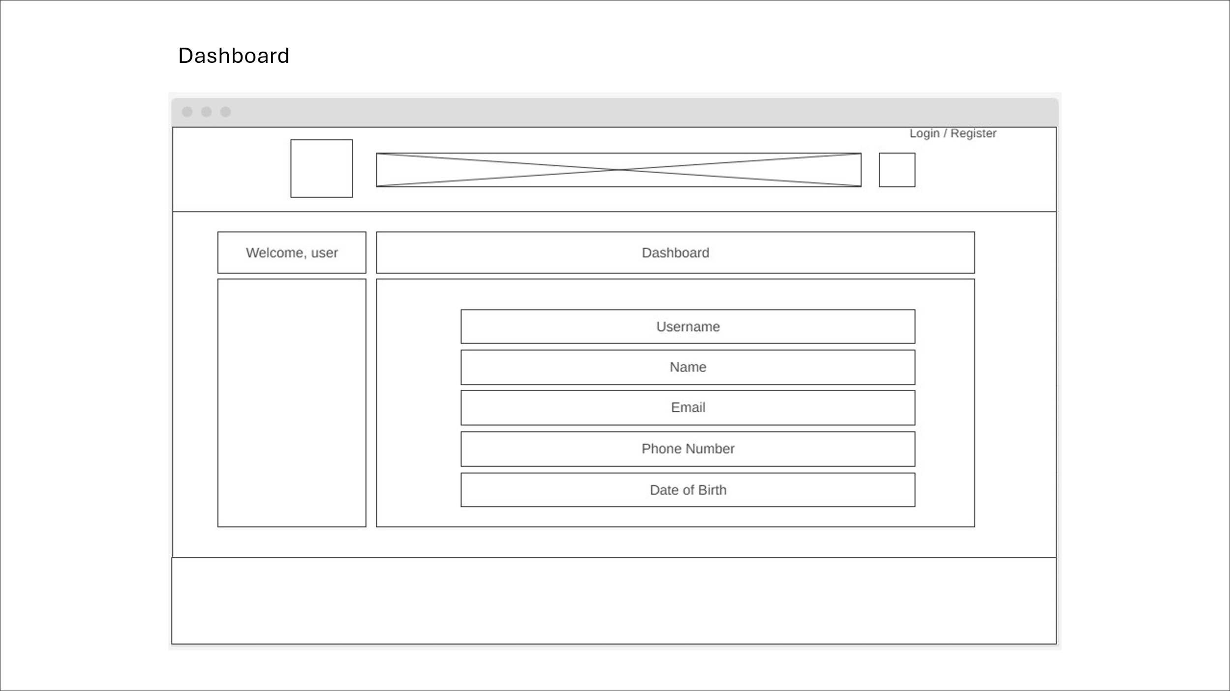

Figure 28 – Wireframe For Dashboard Page

3.7.5 Search Result Page



Figure 29 – Wireframe For Search Result Page

3.7.6 Shopping Cart Page

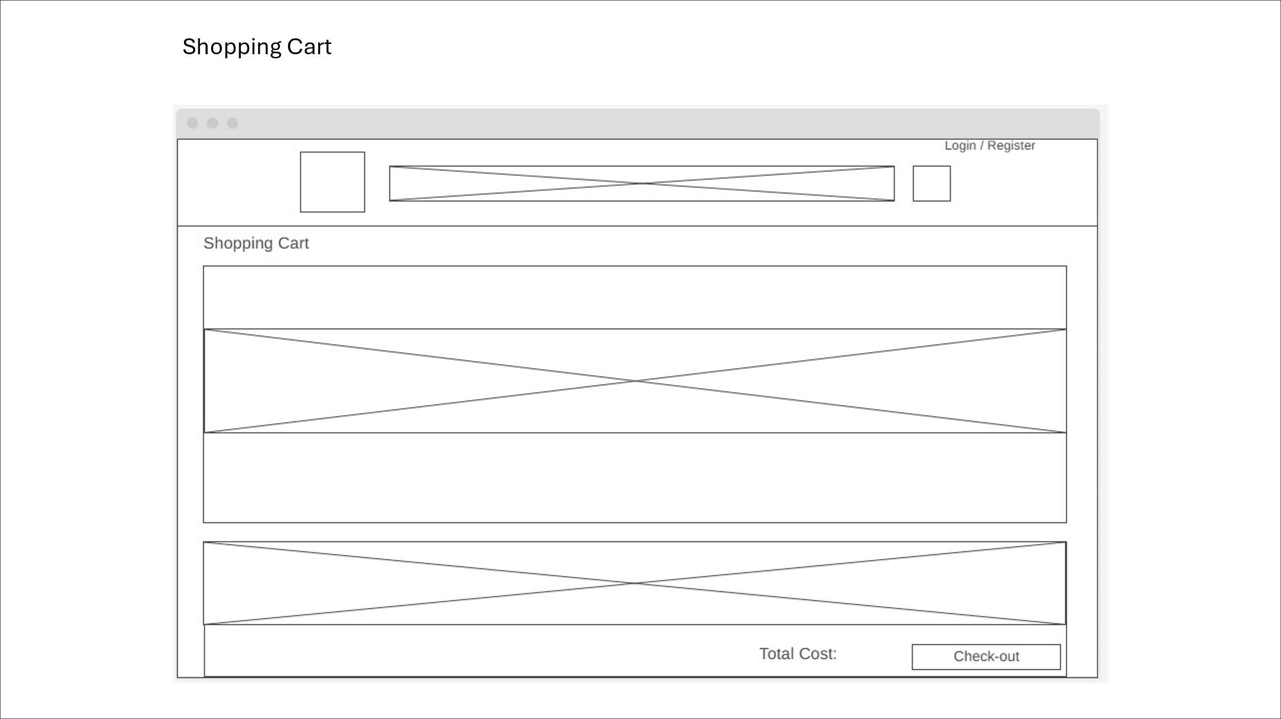

Figure 28 – Wireframe For Shopping Cart Page

3.7.7 Check-out Page

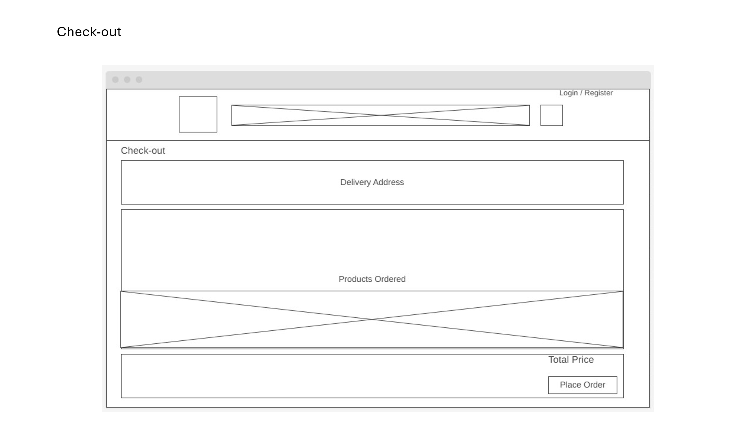

Figure 29 – Wireframe For Check-out Page

All wireframe blueprints are very reusable for both the Client and Seller Client side. Even for future scaling purposes, it can serve as a reference for future development.

3.8 **User Interface / User Experience Drafting**

The UI Drafting stage is where wireframes are designed into an actual webpage to visualize the look and the experience of the web application. This phase is very crucial as it lays out the concept of the whole web application and for future scaling. All branding elements, colour schemes, icons and interactions are determined during this phase. This phase is not only vital for developers, but it is also vital for Clients to visualise the flow and interactions and provide crucial feedback to help improve the development.

Prerequisites:

The tool that was used for UI Drafting is Microsoft PowerPoint & Figma.

3.8.1 Landing Page

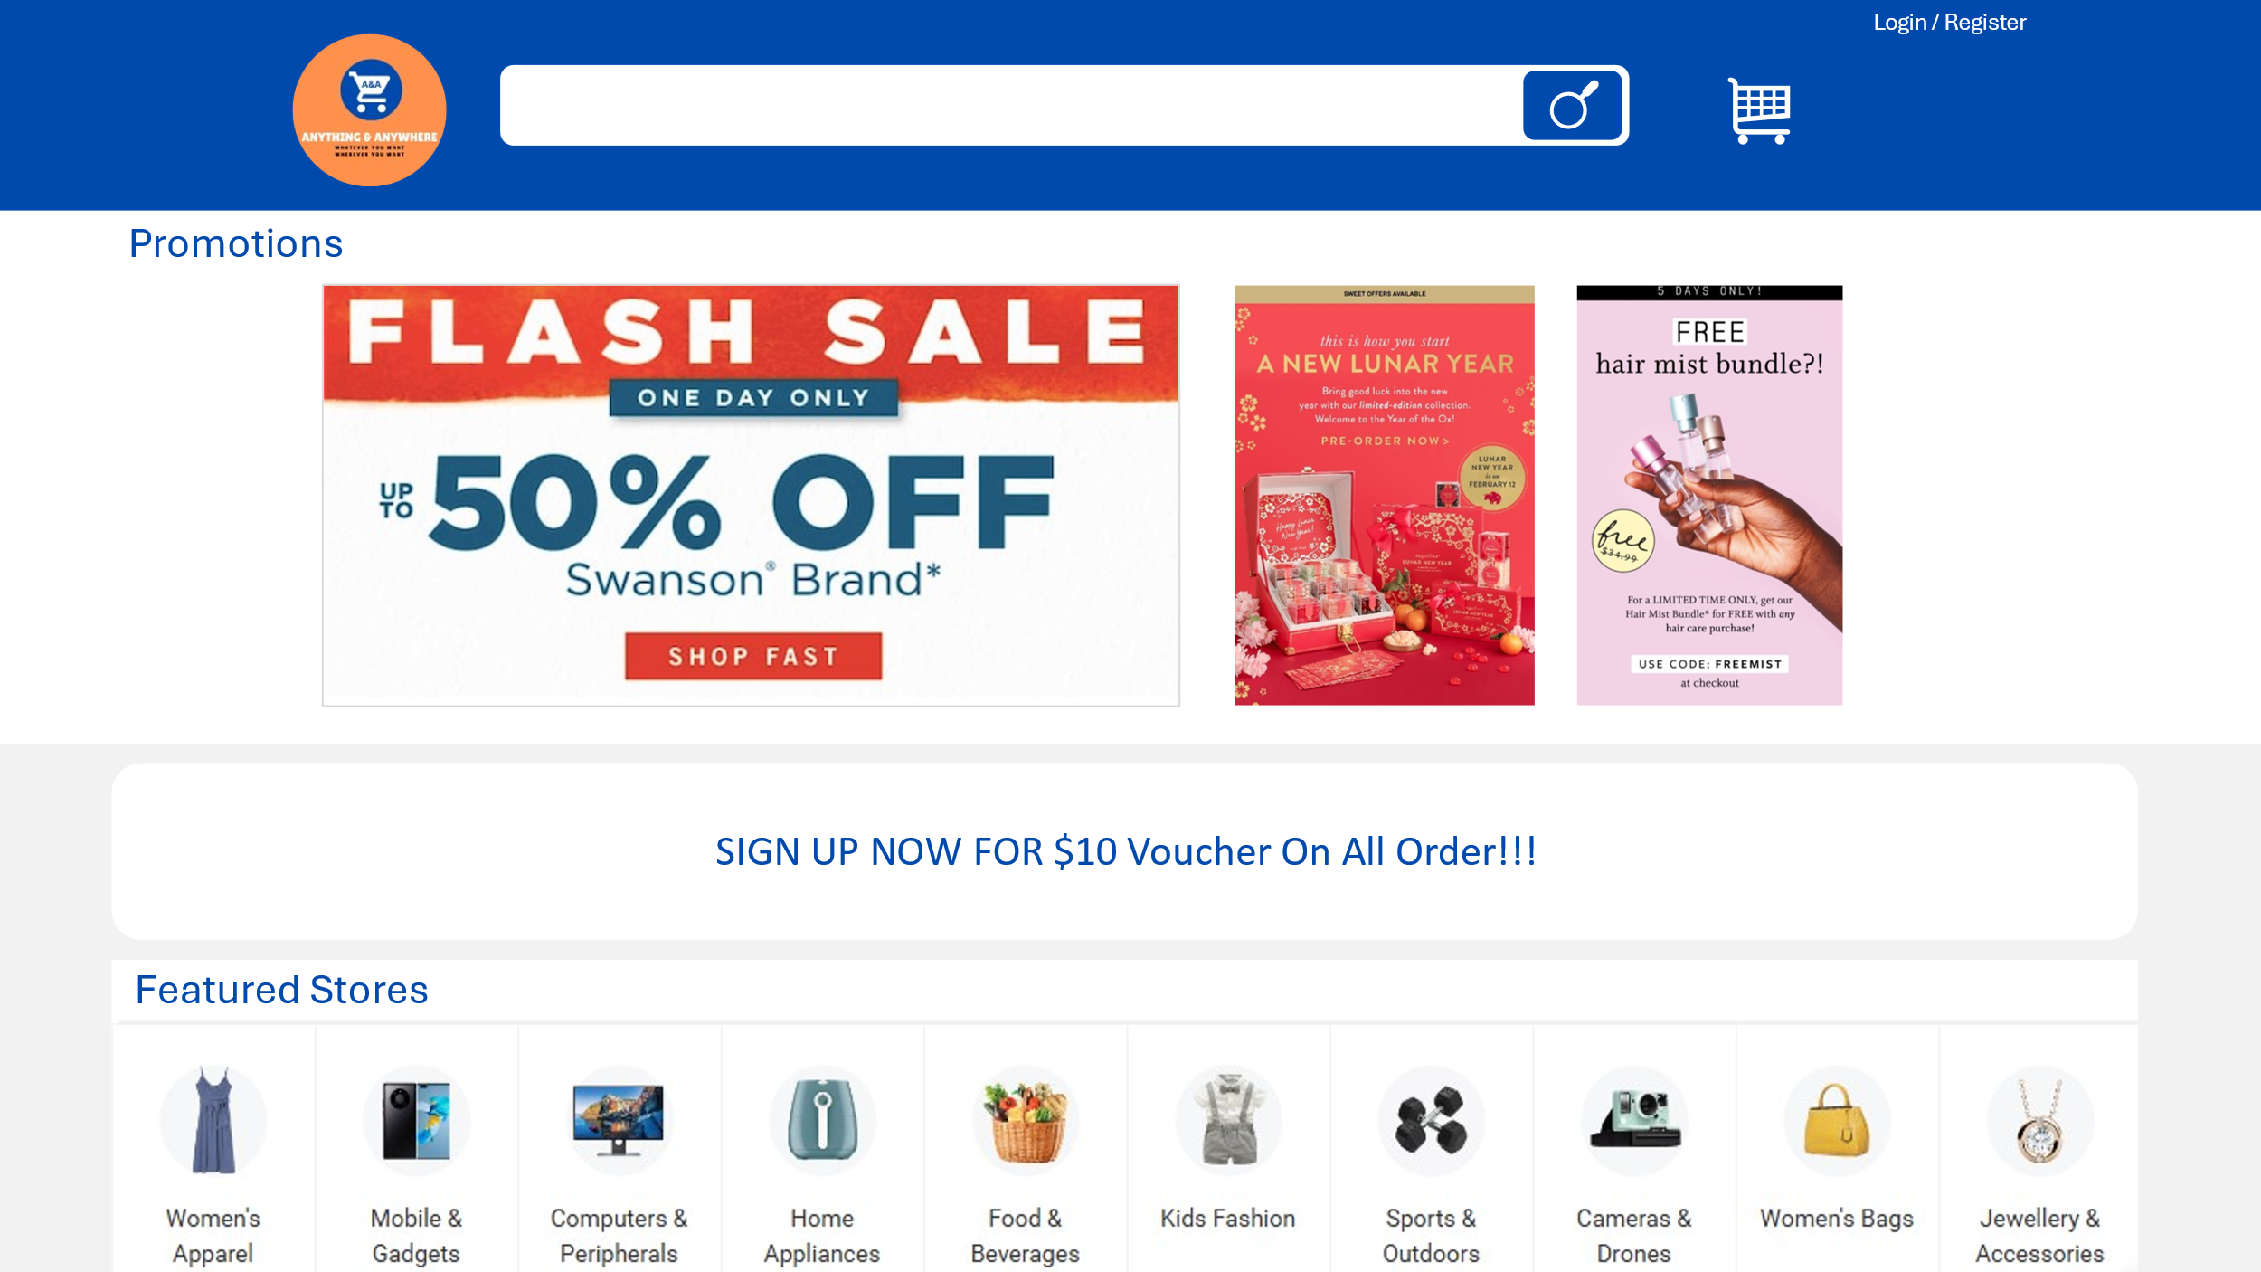

Figure 30 – UI Drafting For Landing Page

3.8.2 Login Page

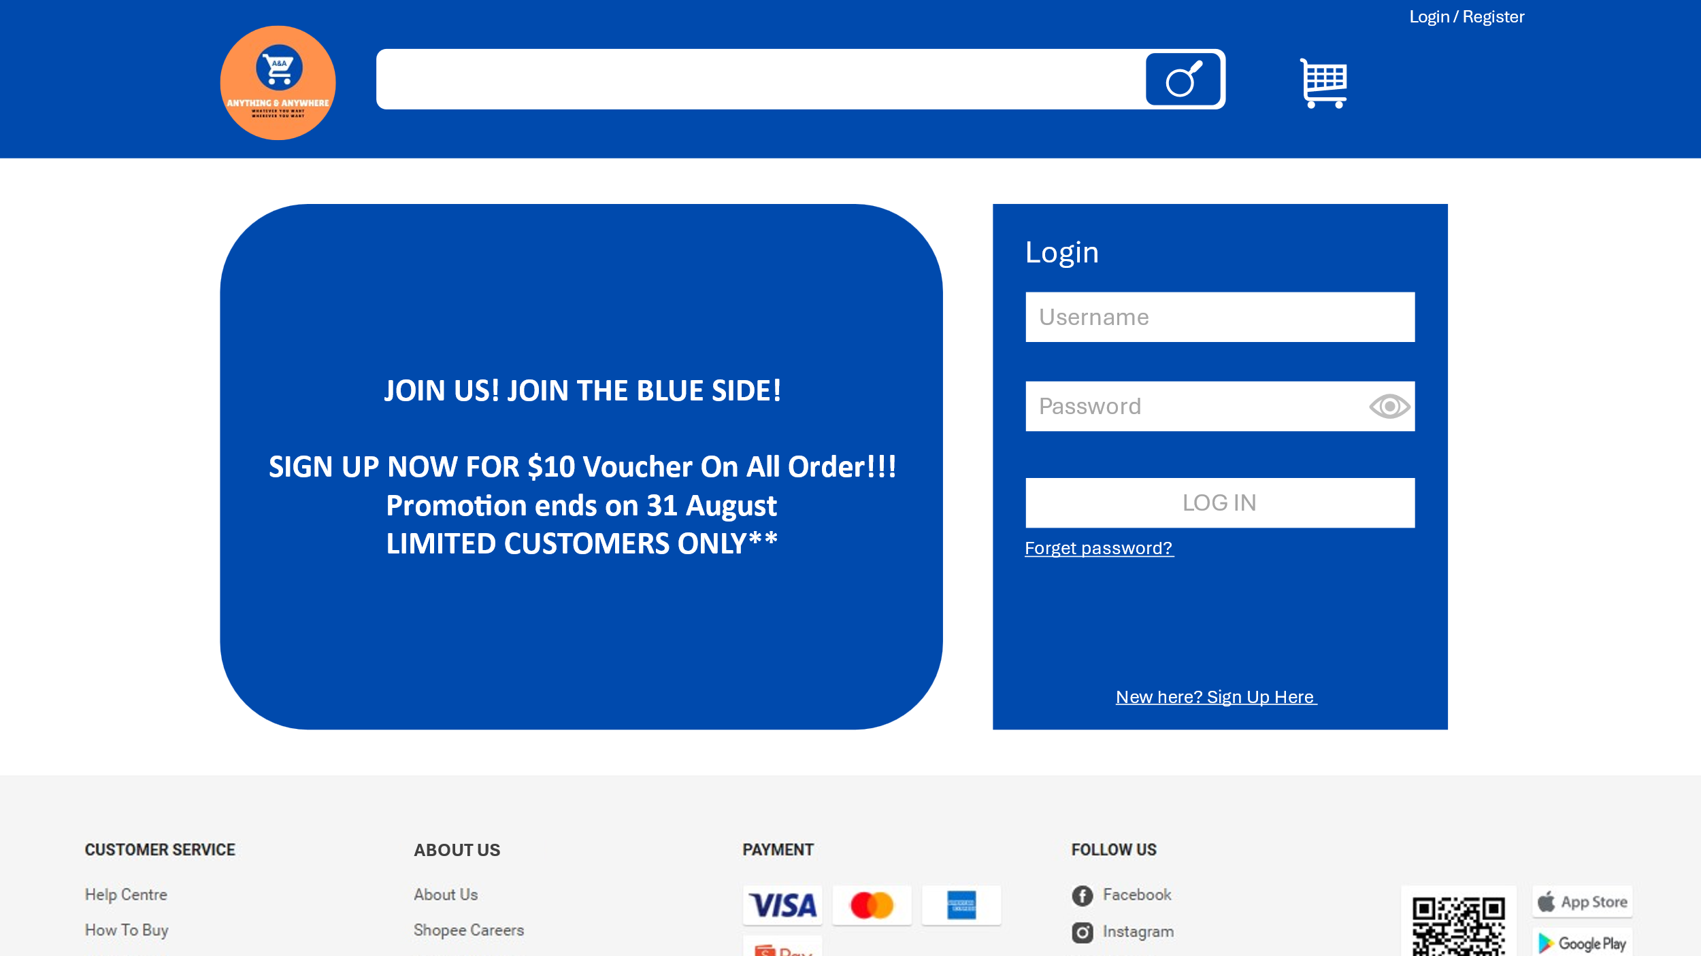

Figure 31 – UI Drafting For Login Page

3.8.3 Register Page

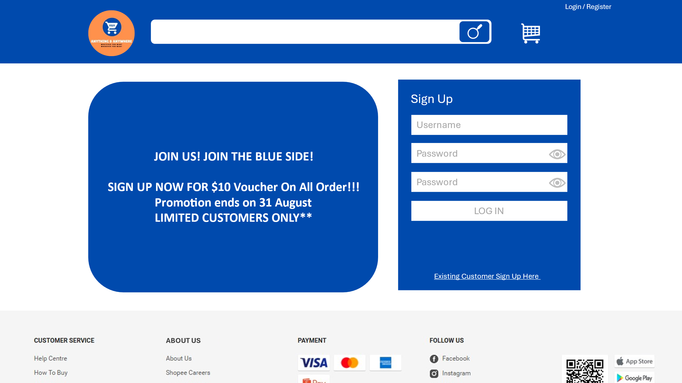

Figure 32 – UI Drafting For Register Page

3.8.4 – Dashboard Page

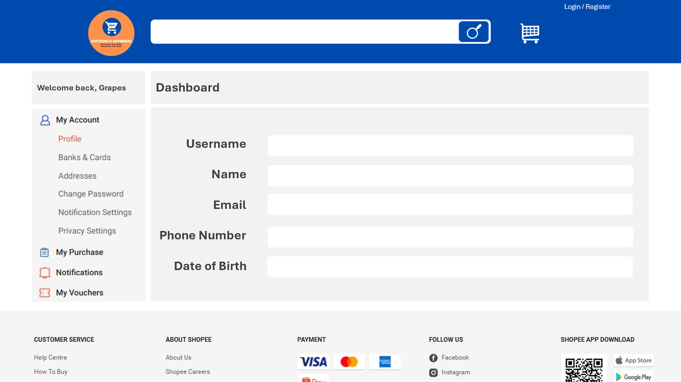

Figure 33 – UI Drafting For Dashboard Page

3.8.5 Search Result

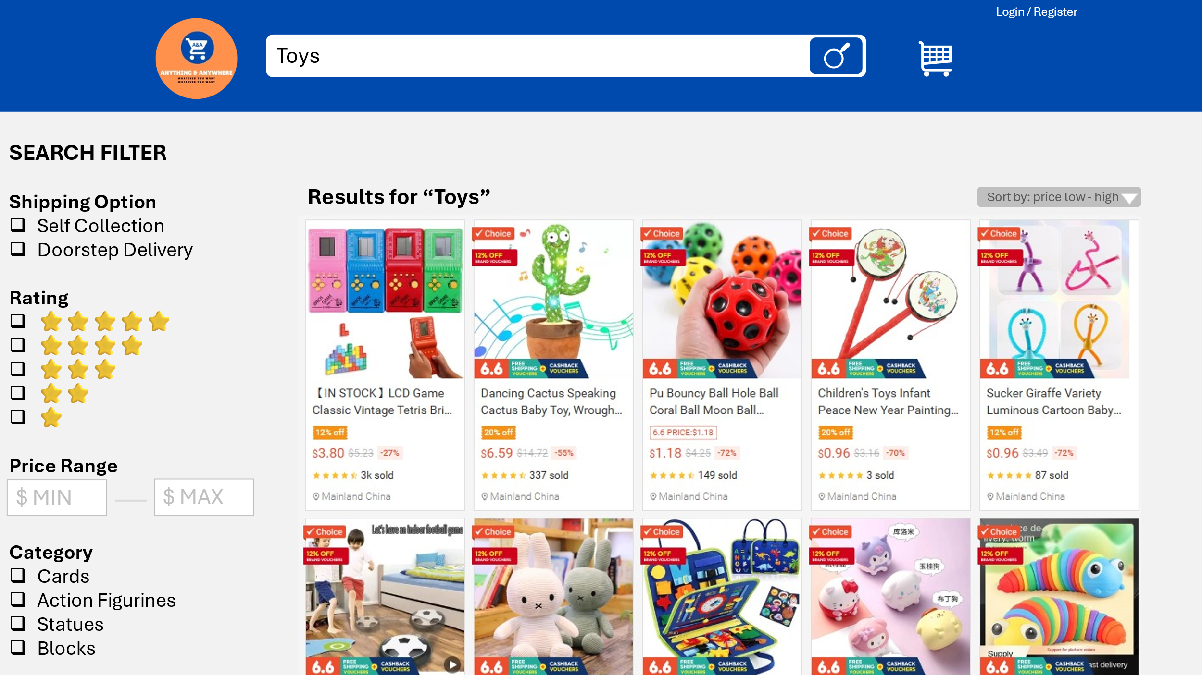

Figure 34 – UI Drafting For Search Result Page

3.8.6 Shopping Cart Page

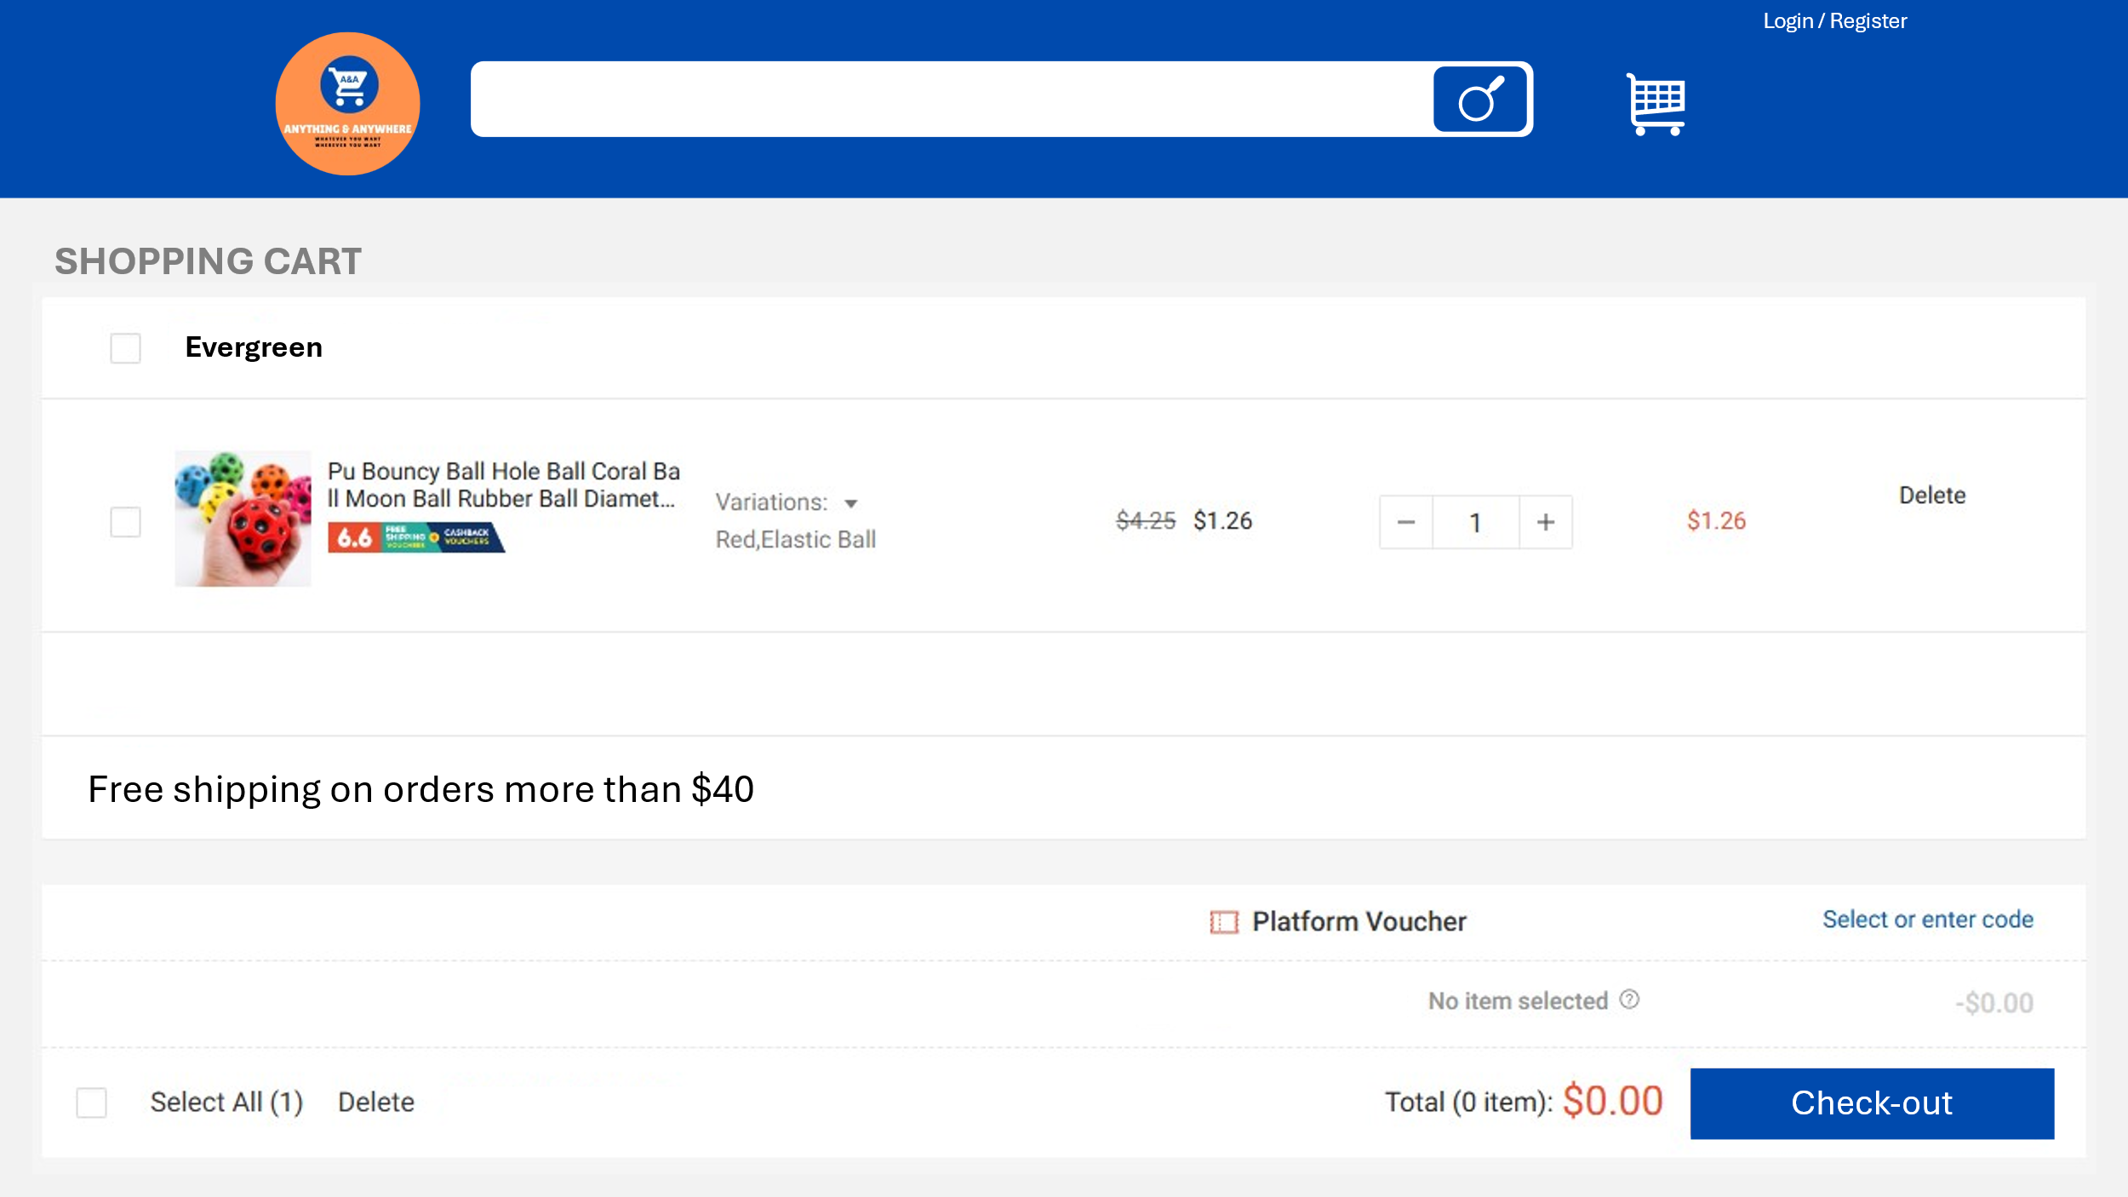

Figure 35 – UI Drafting For Shopping Cart Page

3.8.7 Check-out Page

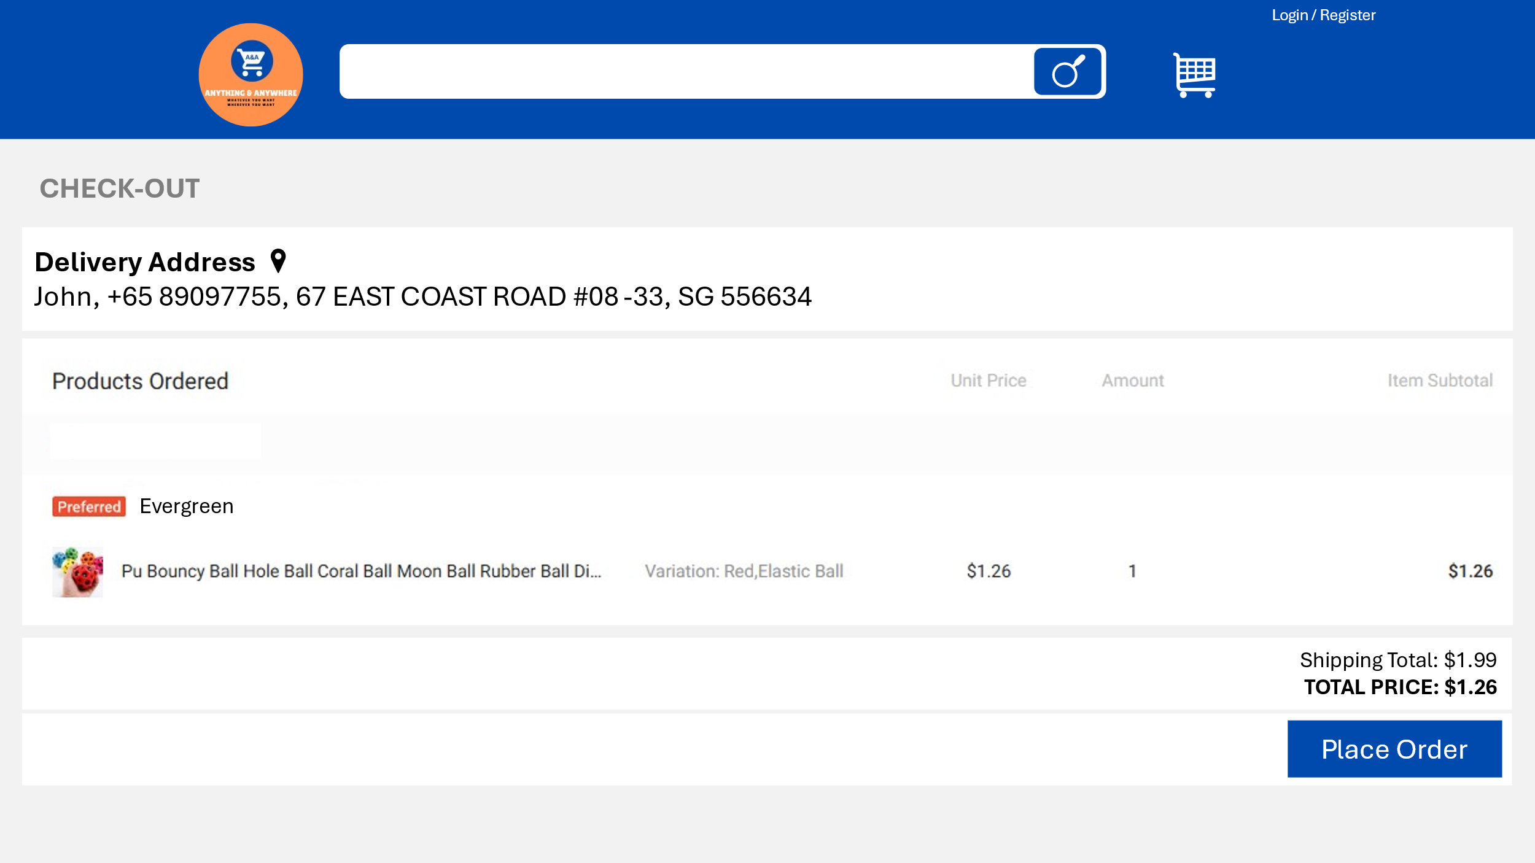

Figure 36 – UI Drafting For Check-out Page

3.9 **Tech Stack**

3.9.1 Frontend (UI/UX)

* HTML
* CSS
* JavaScript
* Bootstrap (Not Implemented)
* React.js (Not Implemented)

3.9.2 Backend (Server)

* Node.js (localhost:3002)
* Express.js

3.9.3 Database

* MongoDB

3.9.4 UI/UX Design

* Microsoft PowerPoint
* Figma
* Draw.io

3.9.4 Text Editor

* Visual Studio Code
  + VSCode Extension: Bootstrap 4, HTML CSS Support, JavaScript (ES6) code snippets, Live Server, MongoDB for VS Code, GitHub Repositories

3.9.5 MongoDB GUI

* MongoDB Compass (Port:27017)

3.9.6 Project Management

* Jira [CE301 Individual Capstone Project - Backlog - Jira (atlassian.net)](https://kaplan-team-f3u9x974.atlassian.net/jira/software/projects/CE301/boards/2/backlog)

3.9.7 Version Control

* GitHub [GrapeJuicer01/FYP: CE301 Capstone Project Challenge (github.com)](https://github.com/GrapeJuicer01/FYP)

3.9.8 OpenAI API Key

* sk-GjZ3VJ4QCHnt5yohPAewhN1ZdE0IYFiJyi_56bltOUT3BlbkFJesp5lzo1fCogF6_qZkOaqTCuEtA9fprq5a7z-YzYEA

3.10 **System Design**

3.10.1 Architecture Overview

The platform uses a three-tier architecture consisting of:

* Frontend (Client Layer): Manages the user interface and client-side interactions.
* Backend (Application Layer): Handles business logic, APIs, and server-side functions.
* Database Layer: Stores and manages all data, including users, products, orders, and transactions.

3.10.2 Frontend (Client Layer)

The front end is built with HTML, CSS, and JavaScript, providing a responsive, intuitive user interface that works across desktop and mobile devices. Key components include:

* Home Page: Displays featured products, categories, and search functionality.
* Product Pages: Allows users to view product details, add items to their cart, and access seller information.
* Cart and Checkout: Displays cart contents, allows for quantity adjustments, and provides an integrated checkout process.
* User Dashboard: Gives users access to order history, profile settings, and saved addresses.
* Seller Dashboard: Allows sellers to manage product listings, view orders, and access sales data.

3.10.3 Backend (Application Layer)

The backend, built with Node.js and Express.js, handles all business logic, data processing, and API endpoints. It includes:

* Authentication and Authorization: Secure user registration, login, and role-based access control (customers vs. sellers).
* Product and Inventory Management: Manages product listings, inventory updates, and real-time stock levels.
* Order Processing: Manages orders, including order creation, status updates, and notifications for customers and sellers.
* Payment Gateway Integration: Provides secure payment processing, supporting various payment options.
* Data Validation and Error Handling: Ensures data integrity and handles errors gracefully to maintain a smooth user experience.

3.10.4 Database Layer

The database layer uses MongoDB to store structured and unstructured data. Key collections include:

* Users: Stores user information and login credentials (hashed passwords).
* Products: Contains product details, prices, categories, stock levels, and related shop data.
* Orders & Orderitems: Manages customer orders, including order items, payment status, and delivery details.
* Shops: Stores information about individual shops managed by sellers, including contact information and product listings.
* Carts: Tracks items added to each user’s cart before checkout.
* Payment Methods: Stores user payment preferences securely.
* Sellers: Stores seller information and login credentials (hashed passwords).
* Reviews: Store product reviews.

3.10.5 APIs

The system uses RESTful APIs to facilitate communication between the front end and back end. Microservices can be introduced in the future to handle specific features independently, such as payment processing, notifications, and recommendations.

3.10.6 Authentication and Security

* JWT (JSON Web Tokens) are used for session management, enabling stateless authentication and authorization.
* Password hashing (e.g., bcrypt) is applied to protect user credentials.
* HTTPS is enforced for secure data transmission.

Chapter 4: Development

4.1 **Prerequisites**

4.1.1 Libraries

4.1.1.a express

It is a web framework for Node.js to build web applications and APIs.

const express = require('express');

Installation: npm install express

4.1.1.b mongoose

It is an object data modelling library for MongoDB and Node.js. It provides the schema-based solution to model the data.

const mongoose = require('mongoose');

Installation: npm install mongoose

4.1.1.c express-session

It is a middleware for managing client sessions in express applications. This allows the server to store and retrieve user session data.

const session = require('express-session');

Installation: npm install express-session

4.1.1.d websocket

It is a library in Node.js, enabling live communication between clients and servers.

const WebSocket = require('ws');

Installation: npm install ws

4.1.1.e multer

It is a middleware for handling <form id="add-product-form" enctype="multipart/form-data">. This allows users to upload files.

const multer = require('multer');

Installation: npm install multer

4.1.2 Modules

4.1.2 a path

It is a built-in Node.js module for handling file paths.

const path = require('path');

4.1.2 b http

It is a built-in Node.js module to create HTTP servers.

const http = require('http');

4.2 **Let’s Start**

The Anything & Anywhere e-commerce platform is development phase focuses on transforming the initial design concepts, wireframes, and system architecture into a fully functional web application. This phase includes building a responsive user interface, implementing secure server-side functionality, connecting to a robust database, and ensuring seamless integration between all components.

The development process is divided into three main sections: Frontend Development, Backend Development, Database Integration and AI Chatbot Integration.

4.3 **Frontend Development**

Frontend Development: This part of the development focuses on creating an intuitive and visually appealing interface using HTML, CSS, and JavaScript. The frontend design prioritizes ease of navigation, mobile responsiveness, and interactive elements to engage users. Essential features like product browsing, cart management, and the checkout process are implemented to ensure that users can seamlessly shop across multiple stores.

4.3.1 Landing Page Development



Figure 37 – Products Landing Page

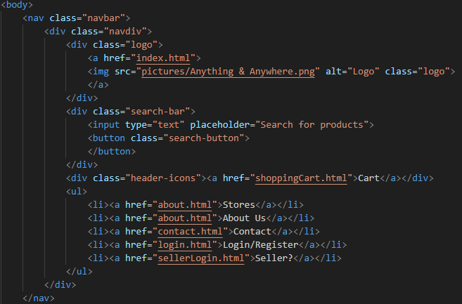

Figure 38 – Code Snippets of Navigation Bar in Landing Page

4.3.2 Bee Cheng Hiang Store Page Development

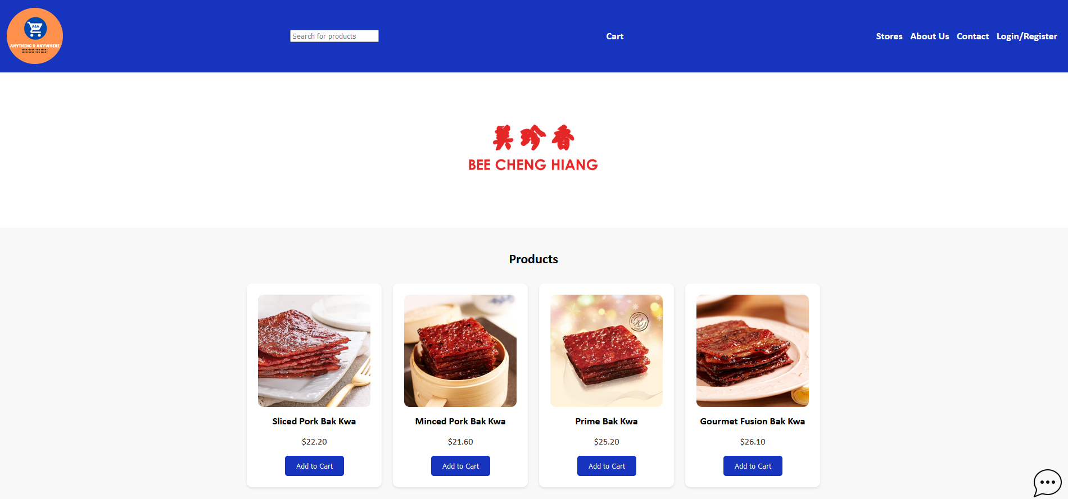

Figure 39 – Bee Cheng Hiang Store Page

Code Explanation. In Figure 39, the products displayed were dynamically rendered from database data. Each product is associated with a specific shop; in this example, shop ID "1" corresponds to "Bee Cheng Hiang." The JavaScript code fetches product data from the database, including the image file path, product name, and price (see Figure 42). This data is then mapped and converted into HTML elements, creating a visually structured product listing. Below each product's price, an "Add to Cart" button is also rendered, allowing users to add items directly to their shopping cart.

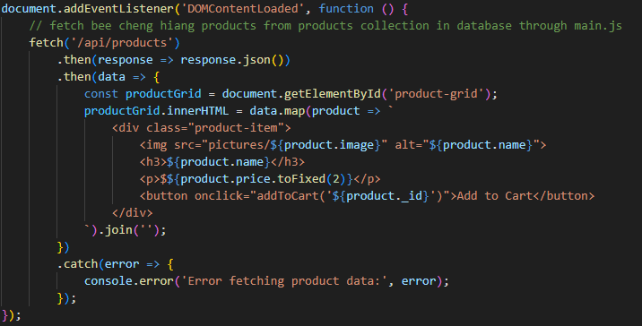

Figure 40 – Code Snippets For Bee Cheng Hiang Store Page Product Rendering (JavaScript)

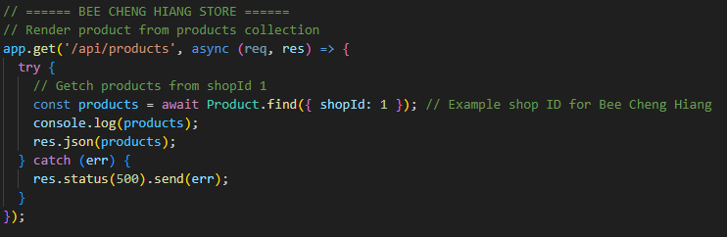

Figure 41- Code Snippets From Main.js (Server Side)

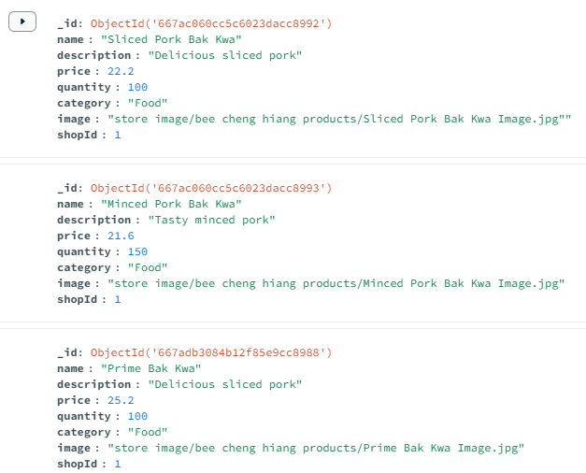

Figure 42 – Products Table In MongoDB Compass

4.3.3 User Dashboard Page Development (Shopper)

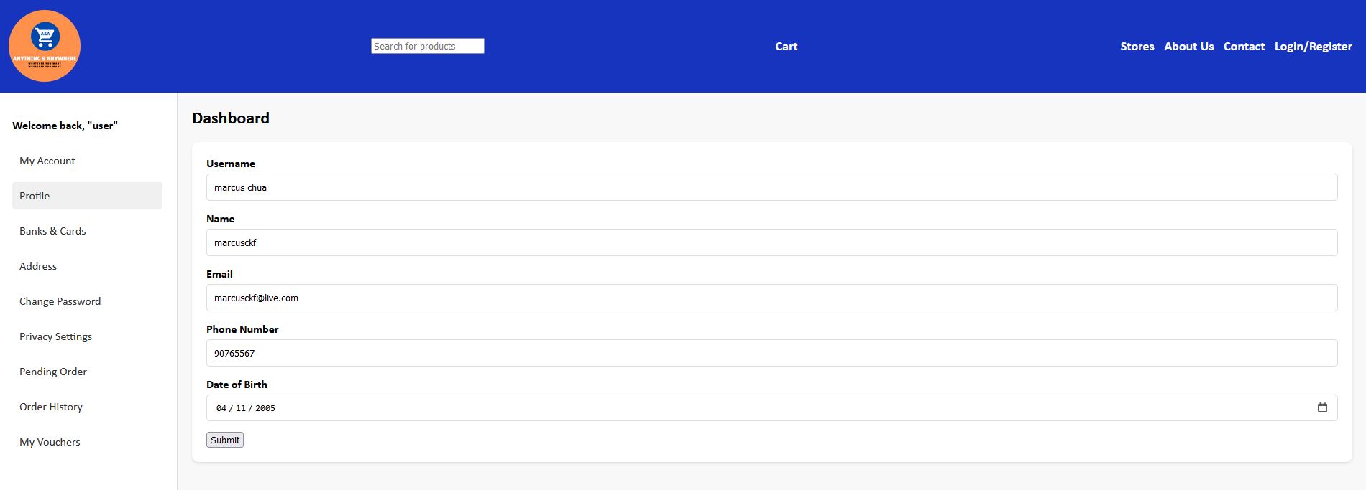

Figure 43 – User Dashboard Page

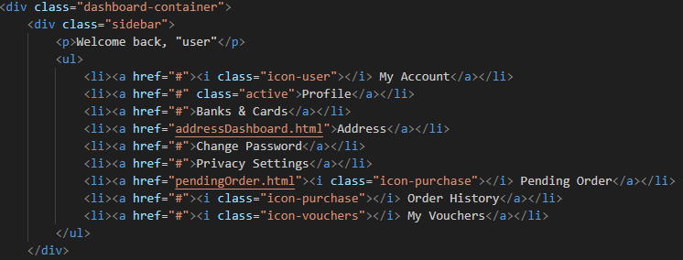

Figure 44 – Code Snippets Of Sidebar Development

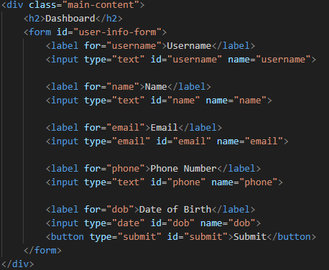

Figure 45 – Code Snippets Of Form Development

4.4 **Backend Development**

Backend Development: The backend is developed using Node.js and Express.js, providing the logic and API endpoints that support core platform functionality. This layer handles data processing, user authentication, order management, and communication between the front end and the database. The backend also ensures secure transactions, error handling, and scalability to accommodate the platform’s growth.

The following is an overview of the APIs implemented, categorized by their functionalities.

4.4.1 User Account Management

Login:

* Endpoint: POST /login
* Purpose: Authenticates users by verifying their email and password, initiating a session upon successful login.

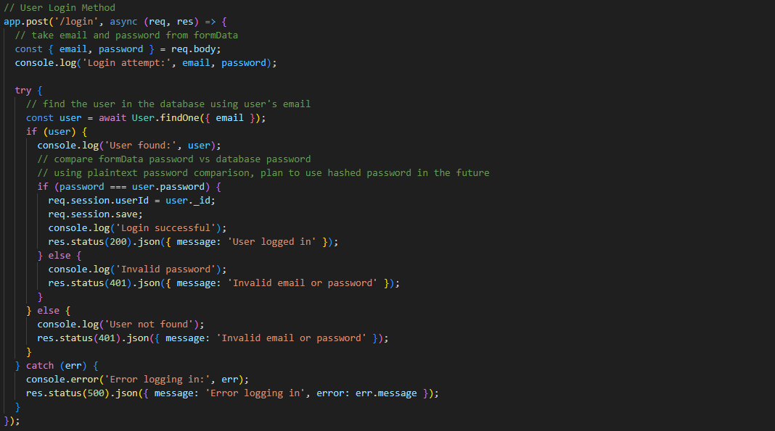

Figure 45 – Code Snippets For Login API

Code explanation: When the Client fills up the formData “login form”, the server will retrieve the email and password from the formData “login form”. Afterwards, it will use the retrieved data and match the User Schema from the Database using email. If the User is found, then the password will be compared to see if matches. If the password matches the session will save the User’s user_id so that the user information can be retrieved via session.

Register:

* Endpoint: POST /register
* Purpose: Registers a new user and saves their credentials.

Session Info:

* Endpoint: GET /api/session
* Purpose: Provides session information to verify if the user is logged in.

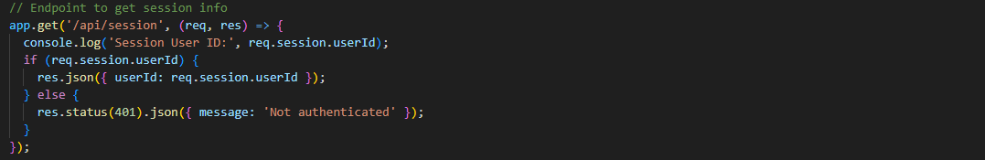

Figure 46 – Code Snippets For Get Session Information API

4.4.2 Seller Account Management

Login:

* Endpoint: POST /api/sellers/login
* Purpose: Authenticates sellers by verifying their email and password, initiating a session upon successful login.

4.4.3 Seller Order Management

View Orders:

* Endpoint: GET /api/seller/orders
* Purpose: Allows sellers to view orders related to their shop, including user information and shipping address.

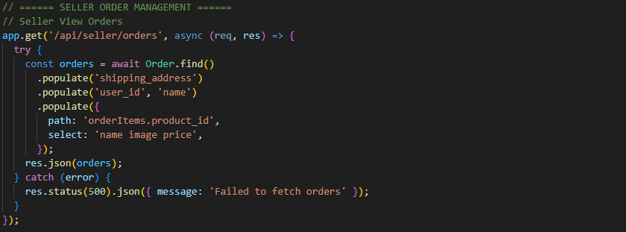

Figure 47 – Code Snippets For Fetching Seller ‘sOrders API

4.4.4 Seller Product Management

Add Product:

* Endpoint: POST /api/seller/products
* Purpose: Allows authenticated sellers to add new products to their shop. Accepts uploading of image.

Code Explanation: This code defines an API endpoint for sellers to add new products. When a POST request is made to /api/seller/products, it first checks if the seller is authenticated and has a valid shopId in the session. If so, it retrieves product details (name, description, price, quantity, category) and an optional image from the request. A new Product object is created with this data, including the shopId from the session and the image path if provided. The product is then saved to the database.

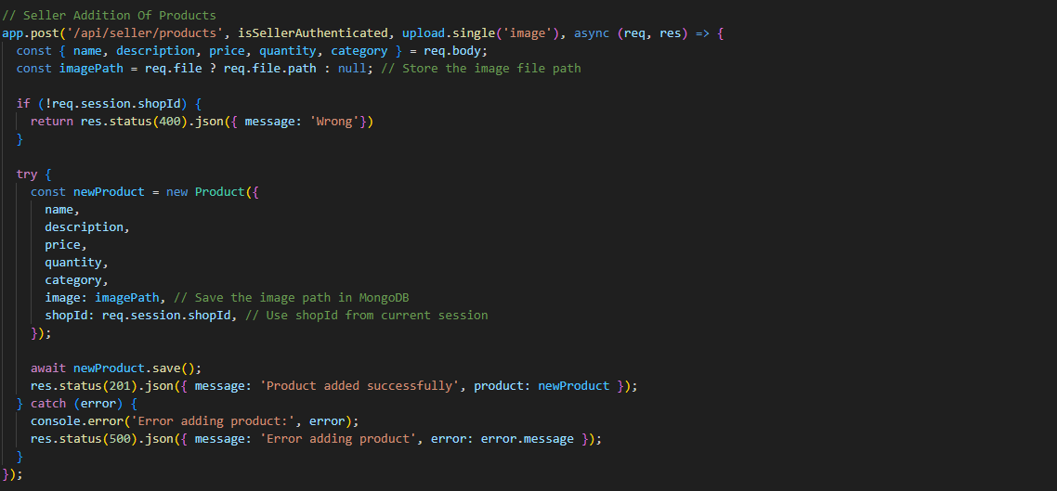

Figure 48 – Code Snippets For Adding Products API

Update Product:

* Endpoint: PUT /api/products/:productId
* Purpose: Enables sellers to update product details, such as name, description, price, quantity, and image. Overwrites the current data in the database.

4.4.5 Shopping Cart

Add to Cart:

* Endpoint: POST /api/shopping_cart
* Purpose: Adds a product to the user’s cart or increments the quantity if already exist.

Delete Cart Item:

* Endpoint: DELETE /api/shopping_cart/:id
* Purpose: Removes an item from the cart by its ID.

Update Cart Item Quantity:

* Endpoint: PUT /api/shopping_cart/:id
* Purpose: Updates the quantity of a specific cart item.

View Cart:

* Endpoint: GET /api/shopping_cart
* Purpose: Retrieves the contents of the user's cart with product details populated.

4.4.6 Order Management

Place Order:

* Endpoint: POST /api/orders
* Purpose: Finalizes the user’s cart as an order, specifying the payment method and shipping address, and clears the cart afterward.

Code Explanation: When a POST request is made to /api/orders, it retrieves payment method, shipping address, and order items from the request body. The user’s cart items are then fetched and checked to ensure the cart is not empty. It also verifies that the shipping address exists for the user. Next, a new order is created and saved to the database with the provided details and a status of "Pending." Then, order items are prepared with details from the cart and bulk-inserted into the "OrderItem" collection in MongoDB.

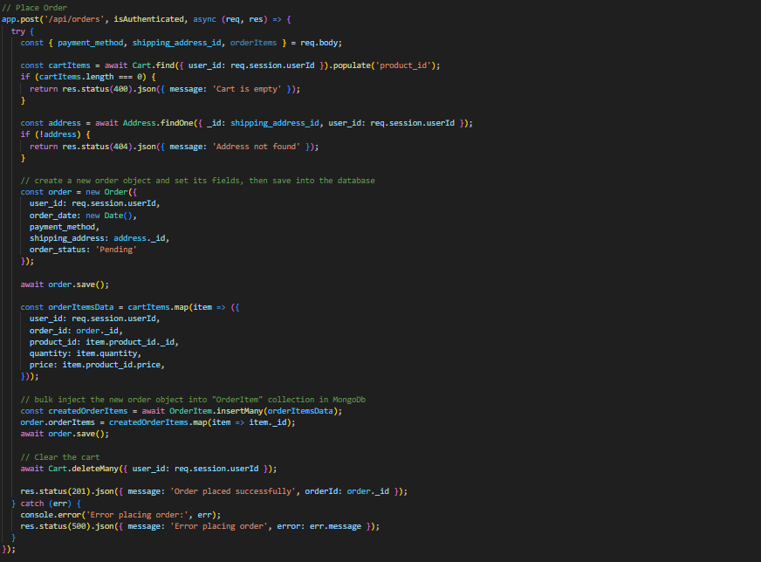

Figure 49 – Code Snippets For Place Order API

4.4.7 User Profile Management

Update Address:

* Endpoint: PUT /api/user_address
* Purpose: Allows users toupdate their shipping address.

Get User Information:

* Endpoint: GET /api/user_info
* Purpose: Retrieves the user’s profile information, such as name, email, and contact details.

Update User Information:

* Endpoint: PUT /api/user_info
* Purpose: Allows the user to update profile details like name, email, phone, and date of birth.

View Orders:

* Endpoint: GET /api/orders
* Purpose: Provides a list of the user's past orders, including order items, shipping address, and order status.

4.4.8 Bee Cheng Hiang Store

View Products:

* Endpoint: GET /api/products
* Purpose: Displays products from the Bee Cheng Hiang store, by shopId (for this case 1).

4.4.9 Middleware

4.4.9.a General Middleware

express.json() and express.urlencoded():

* Purpose: Parses incoming JSON and URL-encoded payloads, allowing the server to handle JSON data and form submissions.
* Placement: Used at the start of the app configuration to ensure all incoming requests are processed.

express.static():

* Purpose: Serves static files like images, CSS, JavaScript, and HTML from the public directory.
* Usage: Allows direct access to files without needing specific API endpoints.

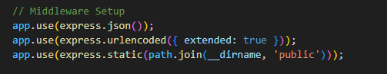

Figure 50 - Code Snippets For General Middleware

4.4.9.b Session Management Middleware

express-session:

* Purpose: Manages user sessions, storing session data on the server and providing persistent user sessions across requests.
* Configuration: Uses a secure session secret and standard options to track and save user sessions.
* Usage: Tracks user authentication and maintains session-based data such as userId for users and sellerId for sellers.

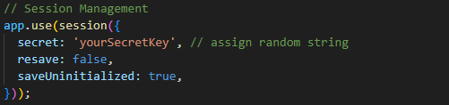

Figure 51 – Code Snippets For Session Management Middleware

4.4.9.c Authentication Middleware

isAuthenticated:

* Purpose: Ensures that only authenticated users can access specific routes. It checks if userId exists in the session.
* Usage: Applied to routes like viewing orders, managing the cart, and accessing user profile info.

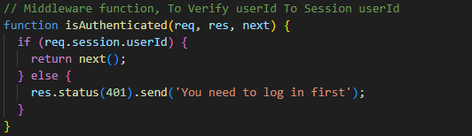

Figure 52 – Code Snippets For Authentication Middleware

isSellerAuthenticated:

* Purpose: Verifies if the session includes sellerId, ensuring only authenticated sellers access seller-specific routes.
* Usage: Applied to seller routes like managing products, viewing orders, and adding new products.

4.4.9.d File Upload Middleware

Multer:

* Purpose: Handles file uploads (e.g., images) in the server, specifically for seller product image uploads.
* Configuration: Uses a disk storage setup to save files in a designated directory (public/pictures/store image/) and adds a timestamp to filenames to avoid duplicates.
* Usage: Applied to routes for adding and updating products where image uploads are needed.

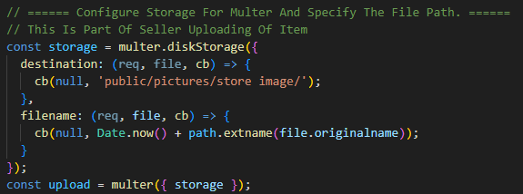

Figure 53 – Code Snippets For Multer Middleware

4.4.9.e WebSocket Middleware

WebSocket (ws):

* Purpose: Establishes real-time communication for features such as live order updates or notifications.
* Configuration: Set up to broadcast messages between connected clients, allowing multiple users to receive messages simultaneously.
* Usage: Handles events like new WebSocket connections, message reception, and client disconnections.

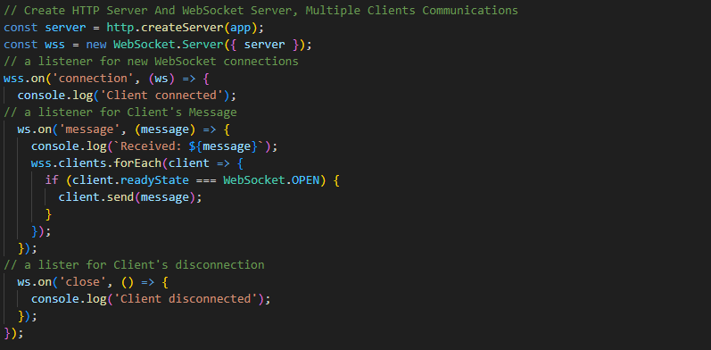

Figure 54 – Code Snippets For WebSocket Middleware

4.5  **Database Integration**

Database Integration: MongoDB, a NoSQL document-oriented database, is chosen for this e-commerce platform due to its flexibility, scalability, and support for complex data structures. MongoDB’s schema-less nature allows for easily managing various collections such as users, products, orders, and inventory without rigidly predefined structures, making it highly adaptable for future expansion of the platform.

4.5.1 MongoDB Integration

Mongoose is an Object Data Modeling (ODM) library for MongoDB and Node.js. It provides a schema-based solution for modeling your application data, making it easier to define and enforce a structure on the documents stored in MongoDB. It also includes data validation, built-in type casting, and middleware support, streamlining interaction between Node.js applications and MongoDB.4.5.2 Connection Setup. Please note that: MongoDB Compass is used as a Graphic User Interface for MongoDB.

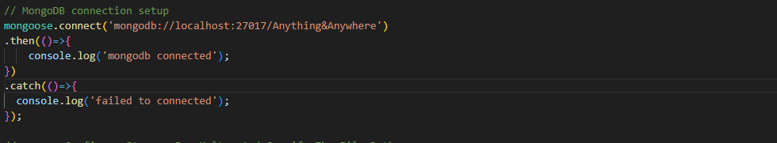

Figure 55 – Code Snippets For Connection To Database

4.5.3 Schema Models

4.5.3.a User Schema

User Schema (users collection)

* Fields: username, name, email, phone, dob, password

4.5.3.b Address Schema

Address Schema (user_address collection)

* Fields: user_id, unit_number, street_number, address_line1, address_line2, postal_code, country

4.5.3.c Product Schema

Product Schema (products collection)

* Fields: name, description, price, quantity, category, image, shopId

4.5.3.d Shop Schema

* Fields: name, image, category, seller

4.5.3.3 Order Schema

Order Schema (orders collection)

* Fields: user_id, order_date, payment_method, shipping_address, order_status, orderItems

4.5.3.f Order Item Schema

Order Item Schema (orderitems collection)

* Fields: user_id, order_id, product_id, quantity, price

4.5.3.g Cart Schema

Cart Schema (shopping_cart collection)

* Fields: user_id, product_id, quantity

4.5.3.h Seller Schema

* Fields: username, email, password, shopId

4.5.4 Mongoose Model

Each Schema is mapped to a Mongoose Mode, which is used to interact with the MongoDB collection.

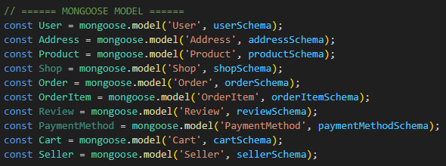

Figure 56 – Code Snippets For Mongoose Model

4.6 **AI Chatbot Integration**

AI Chatbot Integration: The chatbot is embedded in the front end with an intuitive chat window and is accessible across devices. In the backend, the chatbot leverages the OpenAI API for Natural Language Processing (NLP) to understand user queries and provide relevant responses, such as product recommendations, directions and general inquiries.

4.6.1 AI Chatbot Frontend Development

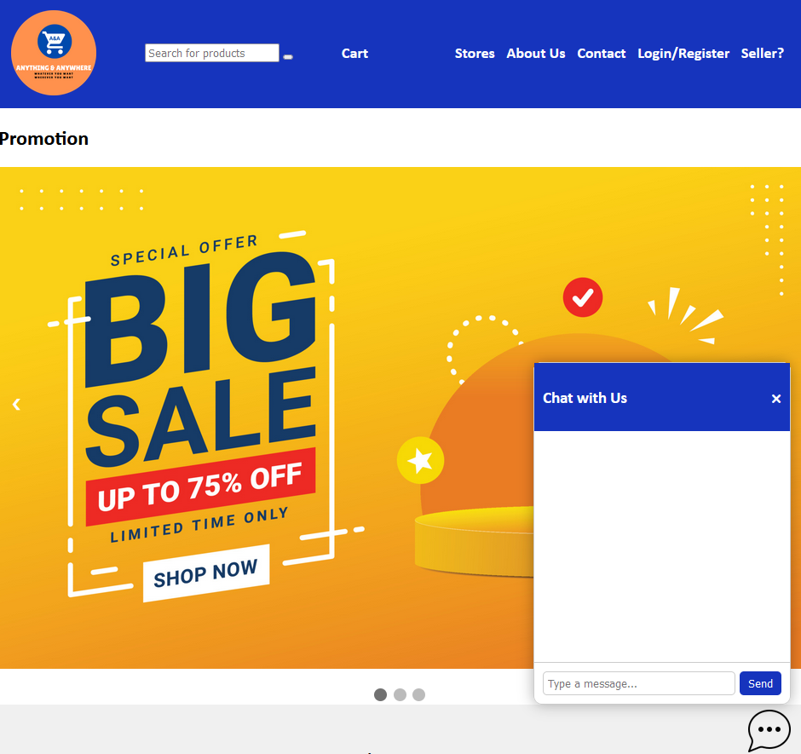

Figure 57 – Chat Window & Chat Icon

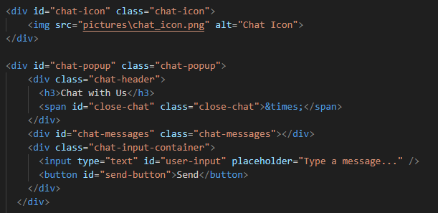

Figure 58 – Code Snippets For Chat Window and Chat Icon

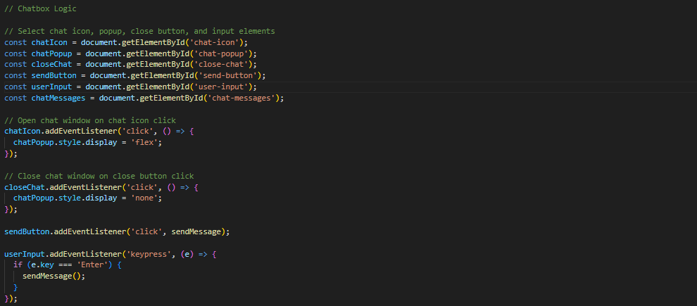

Figure 59 – Code Snippets of Logic For Chat Window and Chat Icon

4.6.2 AI Chatbot Backend Development

The OpenAI Platform page allows users to create personalised AI Assistants. You can give system instructions such as “You are a knowledgeable eCommerce assistant who is based in Singapore. You answer all common e-commerce questions in a polite way.” This sets the behaviour of the assistant, and it will reply in a certain way. There are also multiple models that the user can select from. Please note that different models have different costs. The user can insert files such as reports, databases etc so the assistance can analyse the file and give the user the expected response. For example, I insert my database in JSON format in the file search and prompt the assistant “Recommend me the cheapest bak kwa” results in (figure 61) which is true. The cheapest bak kwa available is minced pork bak kwa. Unfortunately, I wasn’t able to implement such advanced technology in my web-application.

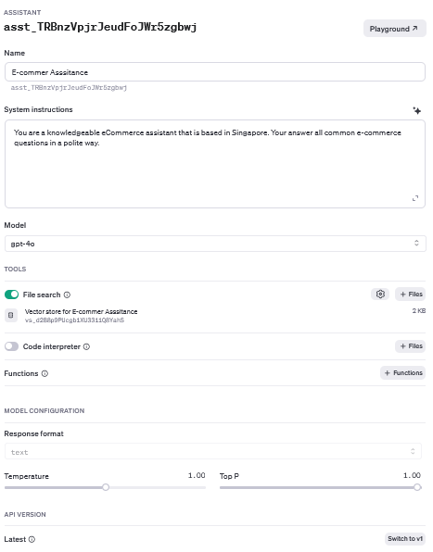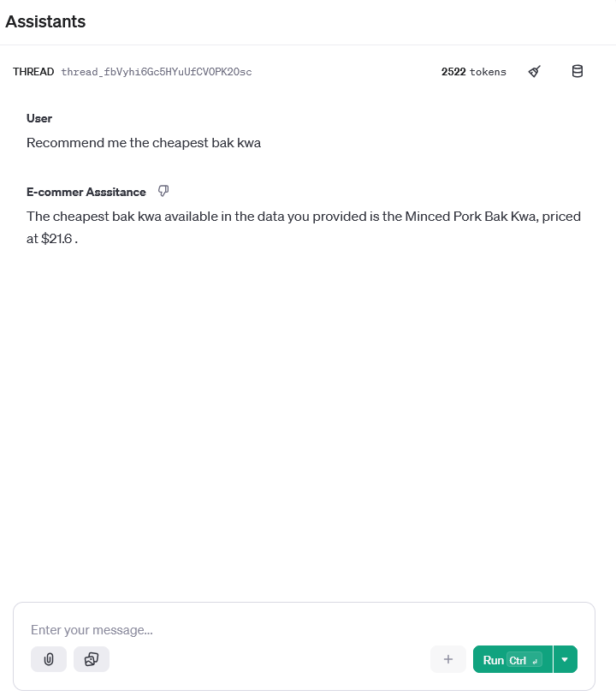

Figure 60 – AI Assistant on OpenAI Figure 61 – AI Assistant Prompting



Figure 62 – Code Snippets of OpenAI API Key and OpenAI Assistant ID.

Code Explanation: When a request is received with a user-provided message, it calls the callOpenAI function to fetch a response from the OpenAI API. The callOpenAI function sends the user's message to the GPT-4 Turbo model, along with system instructions to behave as "You are a knowledgeable eCommerce assistant based in Singapore. Answer all common e-commerce questions in a polite way." The behaviour of the system can be adjusted with just words, for this case it is made for Singapore-based queries. The function includes error handling and retry logic to manage rate-limiting issues by retrying up to three times with increasing delay if a rate-limit error (status code 429) occurs. If successful, it parses the API response and extracts the chatbot's message then the chatbot’s reply is then sent back to the client.

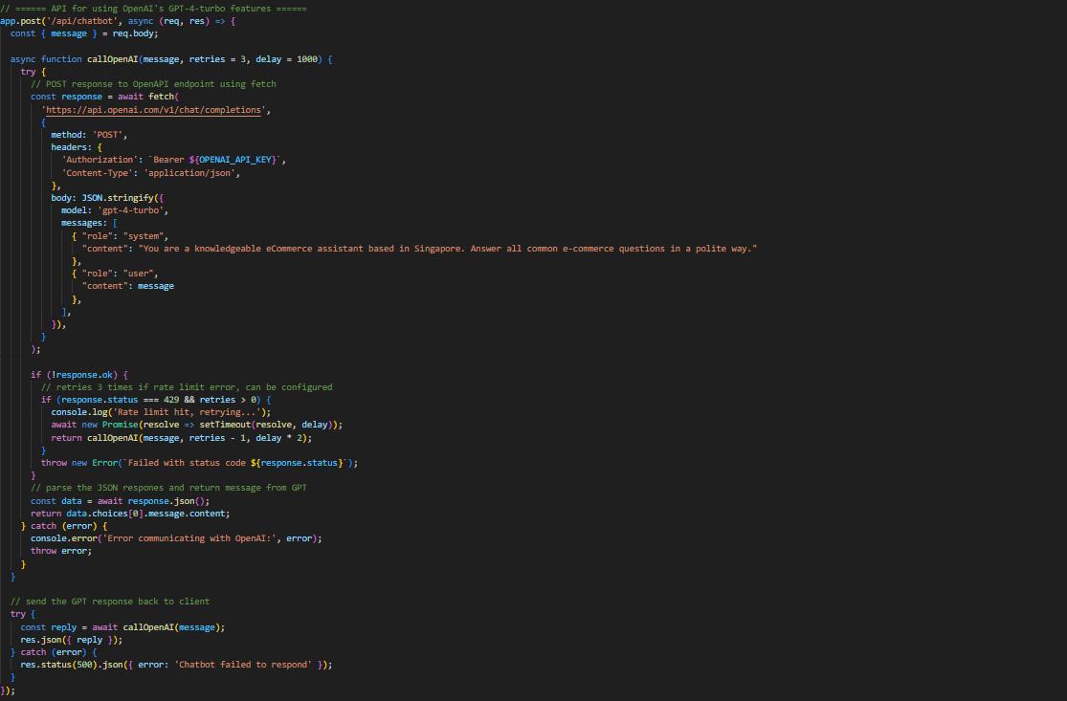

Figure 63 – Code Snippets of Chatbot API

Code Explanation: This code defines a function, sendMessage, that sends a user's input message to the /api/chatbot endpoint. If the message is valid, it displays it in the chat window as the user's message. It then fetches a response from the chatbot API. If a reply is received, it displays the chatbot's response in the chat; otherwise, it shows an error message. The addMessageToChat function adds messages to the chat window and automatically scrolls to the latest message.

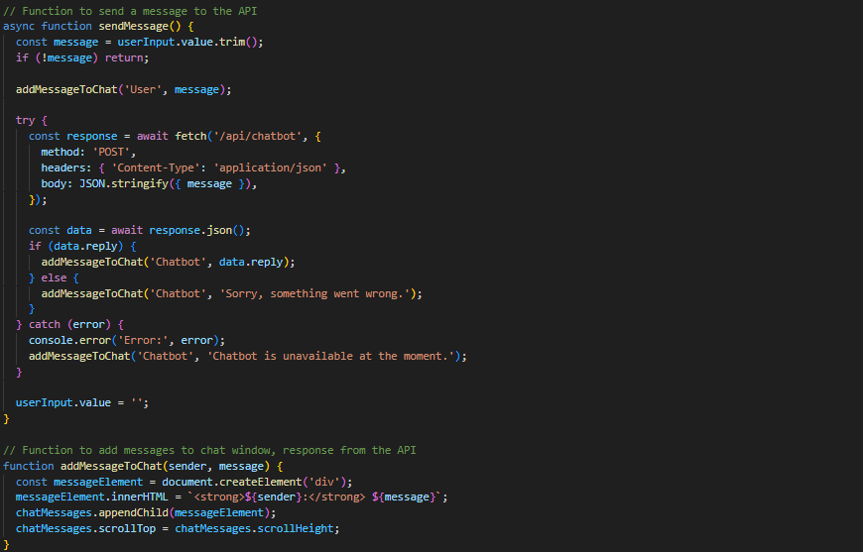

Figure 62 – Code Snippets of Logic For Sending Client Input to Server API

Chapter 5: Testing

5.1 **Functional Testing**

Functional testing focuses mainly on testing each use case to ensure that every user story works as intended. A user acceptance testing will be performed to each user case and the results will be documented.

|  |  |  |  |  |
| --- | --- | --- | --- | --- |
| User Story | User Story | Test Case | Expected Result | Results / Feedback |
| CE301-61 | As a user, I want to be able to view shopping malls so that I can choose preferred shopping locations. | Verify that the user can see a list of shopping malls. | The shopping mall list displays correctly. | Fail |
| CE301-51 | As a user, I want to view shops to know which brand I am buying from. | Check that users can view shops in each shopping mall. | The list of shops display correctly | Pass |
| CE301-79 | As a user, I want to be able to view the product so that I can purchase the desired product | Users can view products tagged to the shop | Product listing displays correctly | Pass, but only “Bee Cheng Hiang” is populated |
| CE301-75 | As a user, I want to be able to view my shopping cart, so that I can checkout | Verify that the user can open the shopping cart page. | The shopping cart page opens, displaying items, quantities, and prices. | Pass |
| CE301-68 | As a user, I want to be able to add item to cart, so that I can collate all my purchase | Confirm items are added to the cart upon selection. | Selected items appear in the cart with accurate details like name, price, and quantity. | Pass |
| CE301-52 | As a user, I want to be able to delete item from the cart so that I can change my order | Ensure that users can delete items from the shopping cart. | Items are successfully removed from the cart, and the cart updates accordingly. | Pass |
| CE301-70 | As a user, I want to be able edit the quantity in the cart, so that I can | Verify that users can increase or decrease item quantities in the cart. | The cart updates to show the new quantity, and the total price adjusts accordingly. | Pass |
| CE301-80 | As a user, I want to be able to view my order history so that I can keep track of my spending | As a user, I want to view my order history to keep track of spending. | Check that order history displays previous orders with accurate details. | Pass |
| CE301-58 | As a user, I want to be able to change my personal information so that the right notification is send to the correction address | As a user, I want to update personal information for correct notifications. | Verify users can edit contact information, such as address and email. | Fail |
| CE301-52 | As a user, I want to be able to change my payment information so that I can make purchase with the chosen payment method | As a user, I want to change payment information to use preferred methods. | Check users can add, edit, or remove payment methods. | Fail |
| CE301-70 | As a user, I want to be able to access my dashboard so that I can use the dashboard functions | As a user, I want to access my dashboard to use dashboard functions. | Dashboard loads with account information, order history, and settings options. | Pass |
| CE301-50 | As a user, I want to be able to delete my account, so that I don't have any ties with the e-commerce | As a user, I want to delete my account to sever ties with the e-commerce platform. | Confirm users can delete their account from the dashboard. | Pass |
| CE301-66 | As a seller, I want to be able to upload products so that shoppers can see | As a seller, I want to upload products to make them visible to shoppers. | Verify sellers can add product details and upload images. | Pass, photo upload has some pathing issue |
| CE301-81 | As a seller, I want to be able to track the inventory of the store, so that I can decide on whether to bring in more stock | As a seller, I want to track store inventory to make stocking decisions. | Check inventory updates accurately when items are added or sold. | Pass |
| CE301-82 | As a seller, I want to be able to see incoming orders, so that I can fulfil the orders | As a seller, I want to see incoming orders to fulfill them. | Confirm that incoming orders list updates in real-time for sellers. | Pass, no function to fulfil the order, only can view |
| CE301-62 | As a seller, I want to be able to delete my account, so that I can withdraw from the system | As a seller, I want to delete my account to withdraw from the platform. | Verify sellers can delete their account from the seller dashboard. | Fail, email to delete for now |
| CE301-65 | As a user, I want to be able to ask the chatbot for assistance so that I can make decisive purchases | As a user, I want to ask the chatbot for assistance to make purchases. | Ensure the chatbot responds to queries with relevant answers. | Pass |

Figure 63 – Table provides a structured summary of functional test cases.

5.2 **Performance Testing**

5.2.1 Response Time

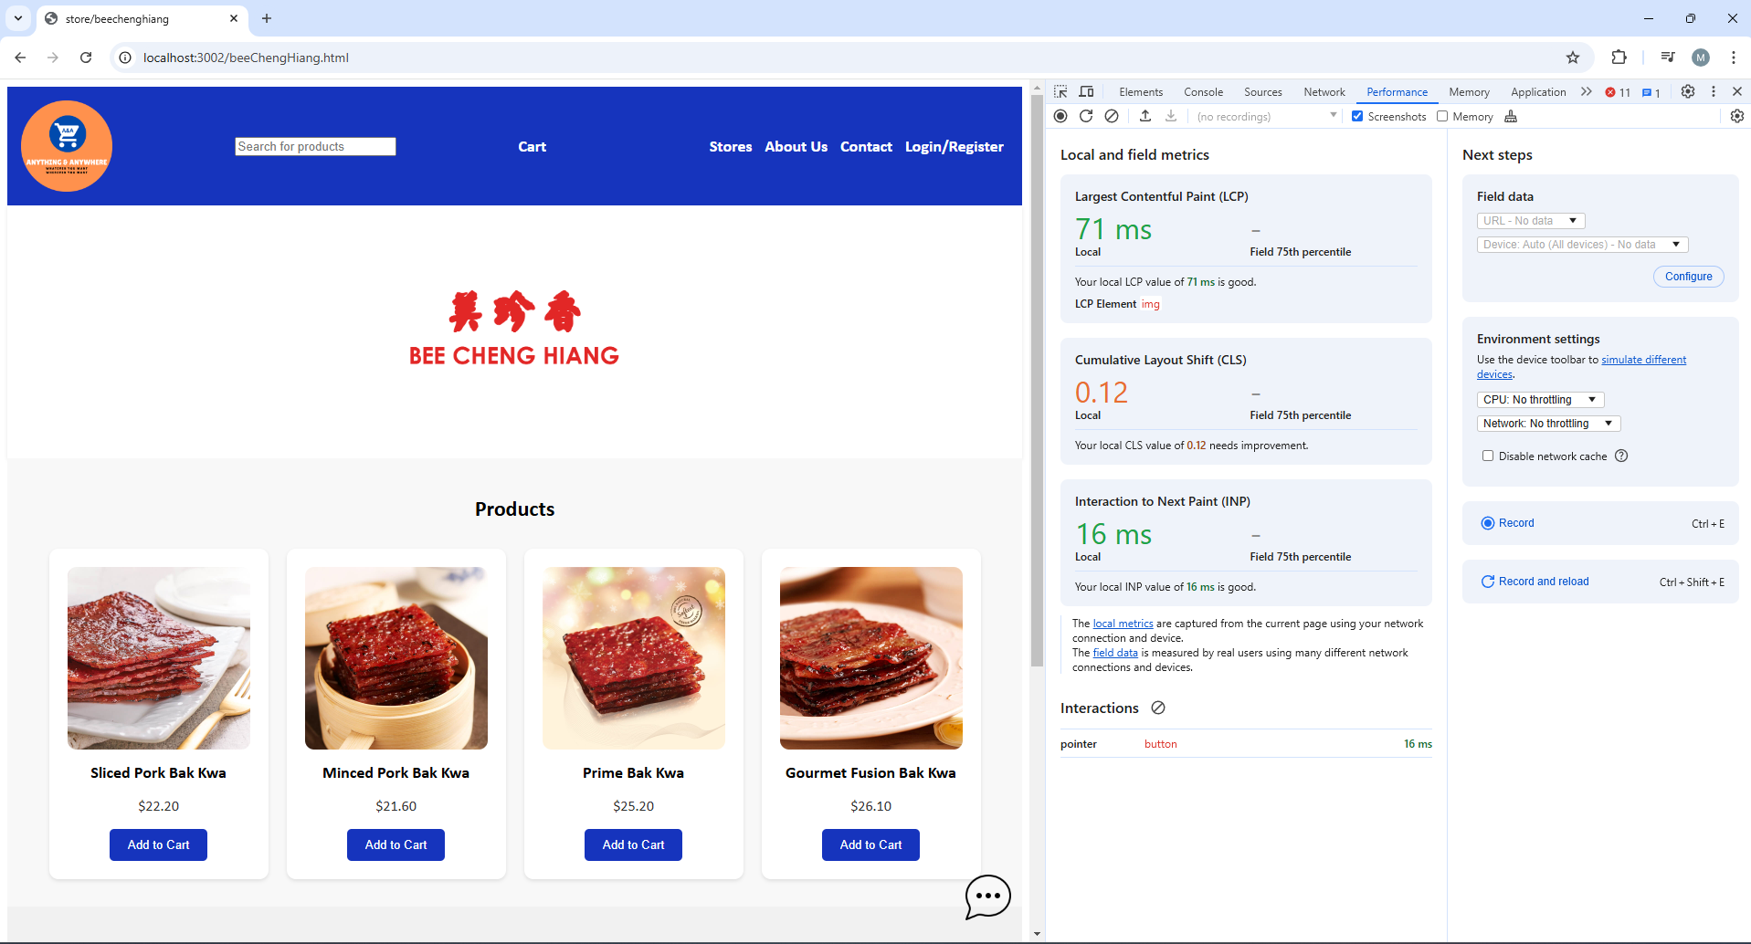

Figure 64 – Screenshot of the Performance

* Largest Contentful Paint (LCP): 71ms – This metric reflects the time it takes for the largest image or text block visible in the viewport to render, which is crucial for the user's perception of page loading speed.
* Cumulative Layout Shift (CLS): 0.12 – Although CLS is not a direct measure of response time, a high CLS can impact the visual stability of the page, causing unexpected shifts in the layout during loading.
* Interaction to Next Paint (INP): 16ms – This indicates the latency between a user interaction (e.g., a click) and the browser's next paint, representing the response time from user input to visual feedback.

The “Add To Cart” button took 16ms to work. I could evaluate the speed almost instantly.

5.2.2 Stress Testing

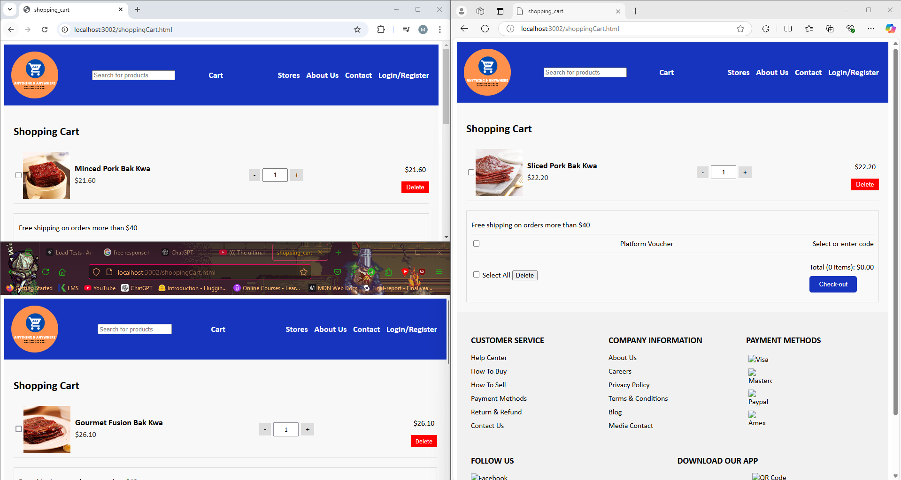

Figure 65 – Screen of Stress Testing For Chrome, Firefox and Edge

The shows that the screenshot in figure 65 can handle multiple users in one session, which means it has the potential to scale.

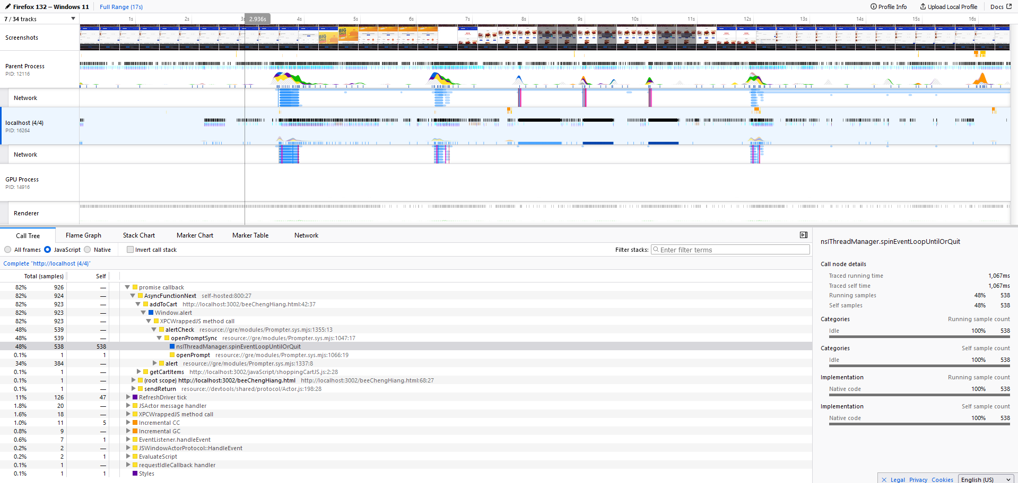

Figure 66 – Screen Shot Of Stress Testing Performance on Firefox.

Traced the Running time of 1067ms, which means the page took around 1 second to complete, including the rendering of elements.

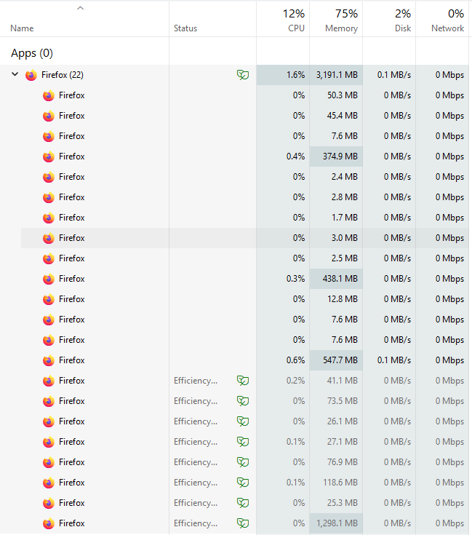

Figure 67 – Screen Shot Of Stress Testing Usage on CPU

5.3 **Compatibility Testing**

Currently, the e-commerce platform's interface is optimized primarily for my screen size and has not undergone extensive compatibility testing across multiple devices and screen resolutions. This limitation means that, while the platform is functional, its user interface may not display optimally on smaller screens, such as tablets or smartphones, or on screens with different aspect ratios.

In future iterations, I plan to improve compatibility by incorporating responsive design practices. A key enhancement will be implementing **Bootstrap**, a responsive front-end framework, which will allow the interface to automatically adapt to various screen sizes. Bootstrap provides a robust grid system, pre-designed responsive components, and mobile-first utilities, making it an ideal choice for enhancing the platform's compatibility and usability across devices. This integration will ensure a seamless user experience across desktops, tablets, and mobile devices, contributing to a more versatile and accessible platform.

5.4 **User Feedback**

5.4.1 Gathering User Feedback

Feedback was collected via in-person interviews and usability testing sessions. Feedback was collected from test users to create a user-centred e-commerce platform. These users were asked to perform common tasks on the platform, such as browsing products, adding items to the cart, managing orders, and using the chatbot for assistance.

5.3.2 Key Areas For Improvement

* User Interface: It is not optimised for different screen sizes, it should be optimised for all screen sizes and mobile device screen sizes
* Order Management For Sellers: Sellers indicated a need for low inventory notifications for low-stock items will help them manage their inventory
* AI Chatbot Response Time: Some users felt that the chatbot response times were slow during peak hours, so feedback was received to optimize the chatbot’s efficiency.

Chapter 6: Project Planning

6.1 **Project Planning With Jira**

Jira was selected as the primary tool for project management, allowing efficient tracking of tasks, monitoring progress, and addressing issues as they arose. Using Jira, the project was broken down into sprints, each focused on delivering specific features or improvements.

* Creating User Stories and Epics: To capture the requirements from both users and sellers, I developed user stories (e.g., “As a user, I want to view products so I can make purchases”) and grouped related stories into Epics (e.g., "User Account Management," "Shopping Cart Features").
* Assigning Story Points: Each user story was assigned a story point value based on complexity and estimated time, helping prioritize tasks for each sprint.
* Sprint Planning and Tracking: Jira’s sprint board allowed the team to organize tasks by priority and monitor their completion, ensuring all tasks remained aligned with the project’s timeline.

6.2 **Risk Management**

6.2.1 Key Risks

* Inconsistent Time Tracking: One of the challenges encountered was remembering to log hours consistently. This sometimes led to gaps in the time tracking data, making it difficult to assess time spent on each task accurately. This oversight also affected the ability to analyse time allocation across different parts of the project.
* Lack of Structured Time Management: Without a structured time management approach, some tasks took longer than anticipated, impacting the project timeline. This led to occasional periods of rushed work to meet deadlines, potentially impacting the quality and thoroughness of the tasks.

6.2.2 Mitigation Strategies

* Setting Regular Reminders for Time Logging: Implementing a reminder system, such as calendar notifications or Jira prompts, can help ensure that hours are logged consistently.
* Using Time-Tracking Tools: Introducing a dedicated time-tracking tool, like Clockify or Toggl, alongside Jira can automate the process of logging hours and reduce the likelihood of oversight.
* Establishing a Weekly Review Process: Regular weekly reviews of completed tasks and time spent can help identify patterns in time management and allow for adjustments as needed.

Chapter 7: Conclusion

This project set out to design and implement an e-commerce platform, "Anything & Anywhere," to streamline the shopping experience for users and enhance business opportunities for store owners. Throughout the project, extensive research, design, development and testing phases were accomplished, they helped me earn very valuable knowledge in web development. From front-end to back-end to database, this project let me have a taste of what a full-stack developer feels like.

7.1 **Achievements**

7.1.1 Key achievements:

* User Experience: The platform offers a seamless shopping journey, from browsing products to checking out. Functional testing confirmed that core user stories, such as viewing products, managing a shopping cart, and completing a purchase, are fully operational.
* Seller and Product Management: The addition of seller-specific features, such as inventory tracking and order fulfilment views, allows business owners to manage their stores effectively. This aspect provides flexibility for sellers, supporting efficient stock and order control. Most importantly scalability
* AI Chatbot Integration: Leveraging the OpenAI API, the chatbot serves as a virtual shopping assistant, guiding users through product recommendations and general inquiries. This feature enhances the user experience by adding a personalized element to the platform.

7.2 **Challenges Encountered**

* Time Management and Risk Tracking: As identified in the risk management section, keeping consistent logs of project hours was challenging. This impacted time tracking and highlighted a need for better time allocation in future projects.
* Compatibility Issues: The platform was initially optimized for a specific screen size, which limited the accessibility and user experience on different devices. Although improvements were made, fully responsive design will be prioritized in future updates, potentially leveraging Bootstrap for optimized layouts.
* Performance Optimization: Testing the platform on a local server limited insights into how it would perform in deployment.
* Knowledge: Web development is new to me, had to take up Colt Steele boot camp for this project.

7.3 **Future Improvements**

* Responsiveness and Compatibility: Implementing a fully responsive design with Bootstrap will ensure that the platform performs well on various devices, particularly mobile.
* Expanded Seller Tools: Additional seller tools, such as low-inventory notifications and more detailed analytics, could enhance inventory management and streamline order processing for business owners.
* Advanced Performance Testing: Deploying the platform on a production server and conducting performance testing under simulated high-traffic conditions will provide more insights into scalability and help identify potential bottlenecks.
* Enhanced Security and Data Privacy: As the platform scales, ensuring data privacy and implementing security measures will be essential. Incorporating user authentication improvements and secure payment processing can add value to the platform.

7.4 **Final Thoughts**

I am very grateful for those mentioned in the acknowledgement. Looking ahead, the skills and knowledge gained from this project, I hope to find a job in similar field.

References

[1] Y. T. Choo, “E-commerce sales in S’pore expected to reach $19.6b by 2027, despite slower growth this year | The Straits Times,” www.straitstimes.com, Sep. 06, 2022. https://www.straitstimes.com/business/e-commerce-sales-in-spore-expected-to-reach-196b-by-2027-despite-slower-growth-this-year

[2] S. Laoyan, “What Is Agile Methodology? (A Beginner’s Guide),” *Asana*, Feb. 02, 2024. https://asana.com/resources/agile-methodology

‌[3] Atlassian, “4 Kanban Principles for Agile Project Management,” *Atlassian*, 2024. <https://www.atlassian.com/agile/project-management/kanban-principles>

[4] S. E. Kohan, “Consumers Say Hassle-Free Returns Are More Important Than Ever,” *Forbes*, Oct. 30, 2022. https://www.forbes.com/sites/shelleykohan/2022/10/30/consumers-say-hassle-free-returns-are-more-important-than-ever